A project report on
NeuroX - 3D NEUROLOGICAL BRAIN SEGMENTATION

Submitted in partial fulfillment for the award of the degree of
Bachelor of Technology
Computer Science and Engineering

by
MANIDEEP SANDIREDDY (22BCE1434)
GOTAM SAI VARSHITH (22BCE1605)
MUNTA SAI KARTHIK (22BCE5060)


SCHOOL OF COMPUTER SCIENCE AND
ENGINEERING

April,2026

A project report on
NeuroX - 3D NEUROLOGICAL BRAIN SEGMENTATION

Submitted in partial fulfillment for the award of the degree of
Bachelor of Technology
Computer Science and Engineering

by
MANIDEEP SANDIREDDY (22BCE1434)
GOTAM SAI VARSHITH (22BCE1605)
MUNTA SAI KARTHIK (22BCE5060)


SCHOOL OF COMPUTER SCIENCE AND
ENGINEERING

April, 2026



DECLARATION

I hereby declare that the thesis entitled “NeuroX - 3D NEUROLOGICAL BRAIN SEGMENTATION” submitted by Manideep Sandireddy (22BCE1434) for the award of the degree of Bachelor of Technology in Computer Science and Engineering, Vellore Institute of Technology, Chennai is a record of bonafide work carried out by me under the supervision of Dr. Jayaram B.
I further declare that the work reported in this thesis has not been submitted and will not be submitted, either in part or in full, for the award of any other degree or diploma in this institute or any other institute or university.

Place: Chennai
Date: Signature of the Candidate



School of Computer Science and Engineering

CERTIFICATE

This is to certify that the report entitled “NeuroX - 3D NEUROLOGICAL BRAIN SEGMENTATION” is prepared and submitted by Manideep Sandireddy(22BCE1434) to Vellore Institute of Technology, Chennai, in partial fulfillment of the requirement for the award of the degree of Bachelor of Technology in Computer Science and Engineering is a bonafide record carried out under my guidance. The project fulfills the requirements as per the regulations of this University and in my opinion meets the necessary standards for submission. The contents of this report have not been submitted and will not be submitted either in part or in full, for the award of any other degree or diploma and the same is certified.

Signature of the Guide:

Name: Dr./Prof.

Date:

Signature of the Examiner Signature of the Examiner
Name: Name:
Date: Date:

Approved by the Head of Department,
(Bachelor of Technology in CSE)

Name:
Date:
ABSTRACT

The accurate and timely diagnosis of neurological conditions, particularly brain tumors, ischemic strokes, and Alzheimer's Disease (AD), remains a critical challenge in modern clinical neuroradiology. This report presents NeuroX, a clinically-viable, automated artificial intelligence diagnostic assistant engineered for the simultaneous multi-label detection, segmentation, and quantification of multiple brain pathologies from Magnetic Resonance Imaging (MRI) scans. NeuroX employs a novel dual-path asymmetric 3D Convolutional Neural Network (CNN) architecture designed to handle the distinct spatial characteristics of both focal lesions and diffuse neurodegeneration. The first pathway utilizes a Shared Encoder integrated with a Transformer Bottleneck to process multi-sequence MRI inputs (T1ce and FLAIR), directing extracted features into specialized U-Net decoders for precise spatial reconstruction of brain tumors and strokes. The second, independent pathway features an Alzheimer Encoder utilizing 3D Residual Blocks paired with Squeeze-and-Excitation (SE) attention mechanisms to process structural T1-weighted MRIs, effectively capturing the global cortical atrophy patterns indicative of Alzheimer's Disease. The architecture inherently incorporates epistemic uncertainty quantification utilizing Monte Carlo Dropout to prediction branches to generate reliable confidence scores for every diagnosis. The system is augmented by the Heidelberg Brain Extraction Tool (HD-BET) for medical-grade skull stripping, enabling high-fidelity, anatomically accurate 3D interactive mesh visualizations of patient pathology. The framework was trained and rigorously validated across an aggregated multi-domain dataset utilizing a 48-epoch phase-aware curriculum. Data sources included the BraTS 2020/2021 cohorts for tumor segmentation, the ISLES 2022 dataset for stroke, and preprocessed ADNI cohorts for Alzheimer's classification. The trained model achieved notable validation performance, recording a Whole Tumor (WT) Soft Dice score of 0.8902, an Enhancing Tumor (ET) Dice of 0.7637, and a Stroke Dice of 0.5005. Statistical robustness was validated utilizing true nested cross-validation, decision curve analysis, and temperature scaling, achieving optimal calibration. Ultimately, NeuroX bridges the gap between deep learning research and practical clinical utility by providing a comprehensive, uncertainty-aware, multi-disease engine that seamlessly integrates spatial biometric quantification with automated radiological insight.
ACKNOWLEDGEMENT

It is my pleasure to express with deep sense of gratitude to Dr.Jayaram B
Associate Professor, School of Computer Science and Engineering, Vellore Institute of Technology, Chennai, for his constant guidance, continual encouragement, understanding; more than all, he taught me patience in my endeavor. My association with him is not confined to academics only, but it is a great opportunity on my part of work with an intellectual and expert in the field of Medical AI for Neuroimaging.
It is with gratitude that I would like to extend my thanks to the visionary leader Dr. G. Viswanathan our Honorable Chancellor, Dr. Sankar Viswanathan, Dr. Sekar Viswanathan, Dr. G.V. Selvam Vice Presidents, Dr. Sandhya Pentareddy, Executive Director, Ms. Kadhambari S. Viswanathan, Assistant Vice-President, Dr. V. S. Kanchana Bhaaskaran Vice-Chancellor, Dr. T. Thyagarajan Pro-Vice Chancellor, VIT Chennai, Dr. K. Sathiyanarayanan, Director, Chennai Campus and Dr. P. K. Manoharan, Additional Registrar for providing an exceptional working environment and inspiring all of us during the tenure of the course.
Special mention to Dr. Viswanathan V, Dean, Dr. Nithyanandam P, Dr. Suganya G, Dr. Sweetlin Hemalatha C, Associate Deans, School of Computer Science and Engineering, Vellore Institute of Technology, Chennai for spending their valuable time and efforts in sharing their knowledge and for helping us in every aspect.
In jubilant state, I express ingeniously my whole-hearted thanks to Dr. Prassanna J, Head of the Department, B.Tech. Computer Science and Engineering and the Project Coordinators for their valuable support and encouragement to take up and complete the thesis.
My sincere thanks to all the faculties and staffs at Vellore Institute of Technology, Chennai who helped me acquire the requisite knowledge. I would like to thank my parents for their support. It is indeed a pleasure to thank my friends who encouraged me to take up and complete this task.
Place: Chennai
Date: Manideep Sandireddy

CONTENTS

CONTENTS
LIST OF FIGURES
LIST OF TABLES
LIST OF ACRONYMS

CHAPTER 1
INTRODUCTION
1.1 INTRODUCTION AND BACKGROUND….……………………………………. | 1
1.2 MOTIVATION……………………….…………………………………………… | 1
1.3 PROBLEM STATEMENT……………..…………………………………………. | 2
1.4 AIMS AND OBJECTIVES ……………………………………………………… | 2
1.5 SYSTEM OVERVIEW………………..…………………………………………... | 3
1.6 SCOPE OF THE PROJECT……………………………………………………….. | 4
1.7 ORGANIZATION OF THE REPORT ……………………………………………. | 4
CHAPTER 2
BACKGROUND STUDY
2.1 INTRODUCTION TO NEUROIMAGING AND MRI …………………………... | 6
2.2 TARGET NEUROLOGICAL PATHOLOGIES ………………………………….. | 7
2.3 DEEP LEARNING ARCHITECTURES IN MEDICAL IMAGE ANALYSIS…... | 8
2.4 BRAIN EXTRACTION (SKULL STRIPPING) ………………………………..… | 9
2.5 UNCERTAINTY QUANTIFICATION IN CLINICAL AI ………………………. | 9
2.6 STATISTICAL EVALUATION AND CALIBRATION METHODOLOGIES….. | 9
CHAPTER 3
SYSTEM DESIGN AND METHODOLOGY
3.1 INTRODUCTION TO SYSTEM ARCHITECTURE …………………………….. | 11
3.2 DATA PREPROCESSING AND STANDARDIZATION PIPELINE …………… | 13
3.3 THE SHARED ENCODER AND TRANSFORMER BOTTLENECK ………….. | 15
3.4 DISEASE-SPECIFIC PRESENCE HEADS AND SEGMENTATION DECODERS……………………………………………………………………………. | 16
3.5 THE INDEPENDENT ALZHEIMER'S CLASSIFICATION PATHWAY……..… | 16
3.6 TRAINING METHODOLOGY AND 48-EPOCH CURRICULUM …………….. | 17
3.7 LOSS FUNCTIONS AND OPTIMIZATION STRATEGY……………………… | 17
3.8 END-TO-END APPLICATION WORKFLOW ………………………………….. | 17
CHAPTER 4
SYSTEM IMPLEMENTATION & WORKFLOW EXECUTION
4.1 OVERVIEW OF SYSTEM IMPLEMENTATION……………………………….. | 19
4.2 DEVELOPMENT ENVIRONMENT AND COMPUTATIONAL FRAMEWORK | 19
4.3 MODEL TRAINING CURRICULUM AND LOSS FORMULATIONS ……….... | 22
4.4 EPISTEMIC UNCERTAINTY AND CONTINUOUS LEARNING TRIGGER … | 24
4.5 END-TO-END WORKFLOW EXECUTION ……………………………….......... | 25
4.6 AUTOMATED CLINICAL REPORTING ENGINE ……………………..……... | 26
CHAPTER 5
RESULTS, ANALYSIS AND DISCUSSION
5.1 OVERVIEW…………………………………..…………………………………… | 28
5.2 PERFORMANCE METRICS AND EVALUATION CRITERIA ……………… | 28
5.3 QUANTITATIVE RESULTS AND TRAINING DYNAMICS ……………….… | 29
5.4 TUMOR SEGMENTATION RESULTS AND ANALYSIS……………….…….. | 30
5.5 STROKE LESION SEGMENTATION RESULTS………………………………. | 33
5.6 ALZHEIMER’S DISEASE CLASSIFICATION RESULTS…………………….. | 36
5.7 GLOBAL SYSTEM PERFORMANCE AND MULTI-TASK OPTIMIZATION... | 37
5.8 UNCERTAINTY ANALYSIS AND CLINICAL SAFETY……………………… | 38
5.9 VISUALIZATION CAPABILITIES AND SPATIAL RECONSTRUCTION……. | 39
5.10 COMPARATIVE ANALYSIS WITH EXISTING SYSTEMS………………….. | 39
5.11 CLINICAL INTERPRETATION AND UTILITY ……….……………….…….. | 40
CHAPTER 6
CONCLUSION AND FUTURE ENHANCEMENTS
6.1 CONCLUSION…………………………………………………………………….. | 42
6.2 FUTURE ENHANCEMENTS…………………………………………………….. | 43
REFERENCES………………………………………………………………………… 45
APPENDIX……………………………………………………………………………48

LIST OF FIGURES

- BLOCK DIAGRAM………………………………………....……11
- ARCHITECTURE DIAGRAM …………………………………..13
- HIGH LEVEL SYSTEM WORKFLOW………………………….14
- END TO END FLOWCHART ………………………………...….18
- DATA FLOW DIAGRAM…………………..…………………….20
- TUMOR SEGMENTATION ………………….…………………..31
- TRAIN (SOFT) VS VAL (THRESHOLD)………………………...32
- TUMOR VAL HD95 & ASD (MM) – ONLY HD EPOCHS...……33
- STROKE SEGMENTATION…………………...………………….34
- TRAIN SOFT DICE VS VAL DICE/IOU……….…………………35
- STROKE VAL HD95 & ASD (MM) – ONLY HD EPOCHS……..35
- ALZHEIMER VAL: AUC / F1 / ACCURACY…………………….36
- ALZHEIMER VAL: CALIBRATION (BRIER/EUE)…………..….37
- TUMOR MODAL CONFIDENCE…………………………………48
- STROKE MODAL CONFIDENCE………………………………...49
- ALZHEIMER’S MODAL CONFIDENCE…………………………50
- DISEASE PRESENCE CONFIDENCE…………………………….51
- DETECTED PATHOLOGIES………………………………………52
- ANALYSIS DASHBOARD…………………………………………53
- TUMOR VISUALIZATION – VIEW 1……………………………..55
- TUMOR VISUALIZATION – VIEW 2……………………………..55
- STROKE VISUALIZATION – VIEW 1…………………………….56
- STROKE VISUALIZATION – VIEW 2…………………………….56
- REPORT GENERATION DASHBOARD…………………………..58
- FINAL MRI CLINICAL REPORT…………………………………..59

LIST OF TABLES

- TABLE 3.1: DATASET SPECIFICATIONS FOR MULTI-TASK LEARNING……………………………………………………………….…15
- TABLE 4.1: MULTI-TASK LOSS FUNCTION CONFIGURATION.….....23
- TABLE 5.1: BEST VALIDATION METRICS PER PATHOLOGY AND TRAINING PHASE………………………………………………………….30
- TABLE 5.2: TRAINING SESSION SUMMARY (48 EPOCHS TOTAL) …30
- TABLE 5.3: INDEPENDENT LOCAL EVALUATION RESULTS ……….38
- TABLE 5.4: EXISTING VS PROPOSED SYSTEM ………………….…….40
- TABLE 5.5: INDEPENDENT MULTI-SCAN CLINICAL EVALUATION TRIAL………………………………………………………………………...40

LIST OF ACRONYMS

AD | Alzheimer’s Disease
MRI | Magnetic Resonance Imaging
DICOM | Digital Imaging and Communications in Medicine
DWI | Diffusion-Weighted Imaging
FLAIR | Fluid-Attenuated Inversion Recovery
ADC | Apparent Diffusion Coefficient
NIfTI | Neuroimaging Informatics Technology Initiative
PACS | Picture Archiving and Communication Systems
CNN | Convolutional Neural Network
LLM | Large Language Model
MHA | Multi-Head Attention
MLP | Multi-Layer Perceptron
ReLU | Rectified Linear Unit
GELU | Gaussian Error Linear Unit
AMP | Automatic Mixed Precision
AUC | Area Under the Curve
ROC | Receiver Operating Characteristic
DSC | Dice Similarity Coefficient
IoU | Intersection over Union
ADNI | Alzheimer’s Disease Neuroimaging Initiative

Chapter 1
Introduction

  - OVERVIEW AND BACKGROUND
The intersection of medicine and artificial intelligence has catalyzed a paradigm shift in diagnostic radiology. Magnetic Resonance Imaging (MRI) remains the gold standard for non-invasive neuroimaging, offering high-resolution, three-dimensional spatial data of the brain's internal structures without exposing the patient to harmful ionizing radiation. As the global population ages and the prevalence of neurological disorders rises, the volume of MRI scans generated daily has grown exponentially. This surge in data places an immense cognitive and temporal burden on radiologists and neurologists.
Neurological conditions such as brain tumors (e.g., glioblastomas), ischemic strokes, and neurodegenerative diseases like Alzheimer's manifest with complex, heterogeneous imaging signatures. Identifying these subtle morphological changes, accurately quantifying their progression, and distinguishing between overlapping pathologies requires a meticulous slice-by-slice examination of volumetric data. Consequently, the manual segmentation and classification of these scans are not only resource-intensive but also susceptible to human error, fatigue, and subjective bias. Deep learning, particularly 3D Convolutional Neural Networks (CNNs), has emerged as a powerful tool to automate these tasks, demonstrating the ability to extract complex hierarchical features directly from raw voxel data. However, translating these theoretical advancements into practical, trustworthy clinical tools remains a formidable challenge.

  - MOTIVATION
The motivation for the NeuroX project stems from two primary deficiencies observed in the current landscape of medical AI research:
- The Single-Pathology Paradigm: The vast majority of existing AI diagnostic models are narrowly trained to identify a single specific disease (e.g., a model that only segments brain tumors, or a model that only classifies Alzheimer's dementia). In clinical practice, patients frequently present with comorbidities. A patient suffering from Alzheimer's disease may also experience a minor ischemic stroke; a patient with a brain tumor may have underlying age-related atrophy. A model trained exclusively on tumors will silently ignore a massive stroke, potentially leading to catastrophic diagnostic oversights. A holistic, multi-label diagnostic system is critically needed.
- The "Black Box" Problem and Clinical Trust: Deep neural networks are notoriously overconfident, often yielding high-probability predictions even when presented with out-of-distribution or corrupted data. In the high-stakes domain of medical diagnosis, an AI system that cannot communicate its level of uncertainty is inherently unsafe. For clinical adoption to occur, an AI assistant must not only provide a prediction but also quantify its diagnostic uncertainty, flagging ambiguous or highly complex cases for mandatory human expert review.
  - PROBLEM STATEMENT
Current automated neuroimaging analysis tools lack the architectural versatility to perform simultaneous multi-disease detection and segmentation while concurrently communicating predictive reliability. The fundamental problem addressed by this research is the development of a unified computational framework capable of parsing a single 3D MRI volume to independently detect, spatially segment, and visually render brain tumors, strokes, and Alzheimer's disease. Furthermore, the system must overcome the limitations of deterministic neural networks by incorporating robust uncertainty quantification to ensure safe clinical decision support.
  - AIMS AND OBJECTIVES
The overarching aim of the NeuroX project is to architect, train, and validate an advanced, clinically-viable AI diagnostic assistant. To realize this aim, the project is structured around the following specific, measurable objectives:
- Simultaneous Multi-Label Detection: To construct an AI engine capable of analyzing a single MRI input to independently detect Tumor, Stroke, and Alzheimer's Disease, outputting distinct probability scores where the conditions are treated as mutually inclusive.
- Precision 3D Segmentation and Visualization: To engineer an U-Net segmentation decoder that generates anatomically accurate spatial masks for localized lesions, and to translate these segmentations into interactive, color-coded 3D mesh renderings overlaid on a dynamically generated brain surface.
- Medical-Grade Preprocessing Integration: To seamlessly incorporate the Heidelberg Brain Extraction Tool (HD-BET) for accurate skull stripping, ensuring the neural networks process only relevant cerebral tissue and rejecting skull, scalp, and facial artifacts.
- Epistemic Uncertainty Quantification: To implement Bayesian approximations, specifically Monte Carlo (MC) Dropout, across the network's classification heads to generate confidence bounds and uncertainty metrics for every diagnostic prediction, facilitating intelligent clinical triage.
- Clinical Metric Extraction: To transcend basic computer vision metrics (like Pixel Accuracy) by computing real-world clinical quantifications utilizing Affine Matrix transformations, resulting in the extraction of exact lesion volumes in cubic millimeters (mm³), centroid localizations, and world-coordinate bounding boxes.
- Publication-Grade Statistical Validation: To subject the trained models to rigorous evaluation frameworks, including nested cross-validation, reliability calibration (temperature scaling), and Decision Curve Analysis, ensuring the findings meet the statistical rigor required for medical AI research.
  - SYSTEM OVERVIEW
NeuroX is encapsulated within a cohesive, user-friendly Streamlit web application that abstracts the underlying mathematical complexity from the end-user. The workflow begins with the ingestion of raw NIfTI (.nii or .nii.gz) files. The system autonomously manages the entire preprocessing pipeline: Z-score normalization, adaptive spatial padding, and trilinear resampling to a standardized 96x96x96 isotropic voxel space.
The preprocessed tensor is then routed through a highly optimized Deep Learning Architecture containing millions of trainable parameters. A SharedEncoder processes the spatial data, passing its hierarchical features to a TransformerBottleneck3D which employs multi-head self-attention to capture long-range global dependencies. Dedicated PresenceHeads and SegmentationDecoders handle the localization of Tumors and Strokes. Concurrently, to prevent negative transfer and catastrophic forgetting, a structurally independent AlzheimerEncoder v2 analyzes the raw MRI utilizing Squeeze-and-Excitation blocks to detect subtle patterns of cortical atrophy indicative of dementia. Post-processing modules map the segmented outputs back to the patient's original coordinate space, generating comprehensive analytical dashboards and downloadable PDF reports (optionally enhanced with LLM-generated insights via the Groq API).

  - SCOPE AND LIMITATIONS
While NeuroX demonstrates state-of-the-art capabilities, establishing clear boundaries regarding its intended use is paramount.
- Research Prototype: This software is strictly intended for academic research, algorithm development, and educational demonstrations. It is not approved by the FDA, CE, or any regulatory body for clinical deployment.
- Human-in-the-Loop: All outputs generated by the system are assistive and require expert supervision. The AI's predictions cannot replace human clinical judgment, and validations must be conducted by qualified medical professionals such as radiologists or neurologists.
- Data Restrictions: The system is evaluated primarily on structural modalities (T1, T2, FLAIR, DWI/ADC). Users bear the sole responsibility for anonymizing data to ensure compliance with HIPAA, GDPR, and other applicable data privacy laws prior to processing medical images.

  - ORGANIZATION OF THE REPORT
This comprehensive document details the entire lifecycle of the NeuroX system. Chapter 2 provides a critical background study, reviewing the anatomical basis of the targeted diseases and the evolution of 3D CNN architectures in medical imaging. Chapter 3 presents an exhaustive breakdown of the System Design and Methodology, mathematically detailing the customized network components, the multi-phase curriculum training strategy, and the mechanics of uncertainty quantification. Chapter 4 documents the System Implementation and Workflow Execution, illustrating the exact pipeline from raw data ingestion to 3D visualization generation. Chapter 5 offers a rigorous analysis of the Results, Discussion, and Evaluation Metrics derived from both the synthetic integration suite and real-world clinical datasets. Finally, Chapter 6 concludes the report and identifies promising avenues for Future Enhancements.
Chapter 2
Background Study

2.1 INTRODUCTION TO NEUROIMAGING AND MRI
The foundation of modern neurological diagnosis relies heavily on advanced non-invasive imaging modalities. Magnetic Resonance Imaging (MRI) has established itself as the preeminent neuroimaging technique due to its exceptional soft-tissue contrast and its ability to generate high-resolution three-dimensional (3D) representations of the brain without exposing patients to ionizing radiation. MRI utilizes strong magnetic fields and radio waves to generate structural maps of the brain, capturing various tissue properties through different pulse sequences.
The NeuroX system is designed to process standard Neuroimaging Informatics Technology Initiative (NIfTI) file formats (specifically .nii and .nii.gz), which are the universal standard for storing multi-dimensional neuroimaging data. Within clinical and research settings, different MRI sequences highlight specific physiological and pathological features. For instance:
- T1-weighted (T1) and T1-contrast enhanced (T1ce): Highly effective for delineating anatomical structures and identifying enhancing tumor regions.
- T2-weighted (T2): Useful for observing edema (swelling) and identifying general pathological anomalies, as water-rich tissues appear hyperintense (bright).
- Fluid-Attenuated Inversion Recovery (FLAIR): Suppresses the signal from cerebrospinal fluid (CSF), making it exceptionally valuable for identifying cortical and subcortical lesions, such as those associated with stroke or multiple sclerosis.
- Diffusion-Weighted Imaging (DWI) and Apparent Diffusion Coefficient (ADC): Critical for the early detection of acute ischemic strokes by measuring the random Brownian motion of water molecules in brain tissue.

2.2 TARGET NEUROLOGICAL PATHOLOGIES
The human brain is susceptible to a myriad of structural and degenerative diseases. The NeuroX architecture specifically targets three critical, highly prevalent, and often overlapping conditions:
- Brain Tumors (Gliomas): Brain tumors, particularly high-grade gliomas like Glioblastoma Multiforme, are highly aggressive and morphologically heterogeneous. The diagnosis and treatment planning for tumors require precise delineation of sub-regions. In standardized challenges like the Brain Tumor Segmentation (BraTS) 2020 dataset—which forms part of NeuroX's training curriculum—tumors are categorized into three distinct classes: the Enhancing Tumor (ET), the Necrotic Core (NCR), and the peritumoral Edema (ED).
- Ischemic Stroke: Strokes occur when the blood supply to part of the brain is interrupted or reduced, preventing brain tissue from getting oxygen and nutrients. Rapid identification of the ischemic penumbra and the infarct core is a medical emergency. Ischemic stroke lesions can vary drastically in size, from minor focal points to massive volumetric outliers (e.g., lesions exceeding 365,000 mm³), requiring highly robust, binary segmentation models capable of handling extreme scale variations. The ISLES 2022 dataset provides the benchmark for stroke segmentation in this domain.
- Alzheimer's Disease: Unlike localized lesions (tumors and strokes), Alzheimer's Disease (AD) is a progressive neurodegenerative disorder characterized by global brain atrophy, specifically the shrinking of the hippocampus and the enlargement of the ventricles. Diagnosing AD from structural MRI requires a holistic, global view of the brain rather than localized pixel-level segmentation. The Alzheimer's Disease Neuroimaging Initiative (ADNI) provides the standard 3D MRI data for training deep learning models to classify AD versus cognitively normal (CN) subjects.

2.3 DEEP LEARNING ARCHITECTURES IN MEDICAL IMAGE ANALYSIS
The transition from manual radiological assessment to automated computational analysis has been driven by advancements in deep neural networks.
- 3D Convolutional Neural Networks (CNNs): Medical imaging data is inherently three-dimensional. While early AI systems attempted to process MRI scans as a series of 2D slices (discarding spatial depth), modern architectures like the ones employed in NeuroX utilize 3D convolutions (Conv3d) to preserve the spatial integrity of the voxel grid. The fundamental building block of the NeuroX AlzheimerEncoder is the ResBlock3D, which leverages residual connections to alleviate the vanishing gradient problem, allowing for the training of deeper networks capable of extracting complex hierarchical features (e.g., from 1 channel up to 256 channels).
- U-Net and Attention Mechanisms: The U-Net architecture is the industry standard for biomedical image segmentation. It features a contracting path (encoder) to capture context and a symmetric expanding path (decoder) that enables precise localization. NeuroX enhances this via a SegmentationDecoder equipped with AttentionGate3D modules. Attention gates learn to automatically suppress irrelevant background regions while highlighting salient features useful for a specific task (e.g., isolating tumor edema from healthy white matter) without requiring multiple cascaded models.
- Transformer Networks in Vision: Originally developed for natural language processing, Transformers have revolutionized computer vision by capturing long-range global dependencies that CNNs struggle with due to their localized receptive fields. NeuroX incorporates a TransformerBottleneck3D featuring multi-head self-attention (MHA) and feed-forward networks (FFN) to bridge the encoder and task-specific presence heads, ensuring that the network understands the global anatomical context of the brain before generating lesion predictions.
- Squeeze-and-Excitation (SE) Networks: As proposed by Hu et al. (2018), SE blocks explicitly model the interdependencies between the channels of convolutional features. The NeuroX AlzheimerEncoder utilizes an SEBlock with an adaptive average pooling mechanism and a multi-layer perceptron to dynamically recalibrate channel-wise feature responses, emphasizing informative feature maps relevant to Alzheimer's atrophy while suppressing less useful ones.

2.4 BRAIN EXTRACTION (SKULL STRIPPING)
A critical preprocessing step in computational neuroimaging is the removal of non-cerebral tissues, such as the skull, scalp, dura, and facial structures. Failing to adequately skull-strip an MRI scan can lead deep learning models to learn spurious correlations or fail entirely during 3D mesh generation. NeuroX integrates the Heidelberg Brain Extraction Tool (HD-BET), developed by Isensee et al. (2019), which utilizes artificial neural networks to perform highly accurate, medical-grade brain extraction across multisequence MRI data. This isolation of brain tissue is essential for the system's ability to run marching cubes algorithms on the brain mask and generate interactive trimesh 3D surface meshes.

2.5 UNCERTAINTY QUANTIFICATION IN CLINICAL AI
A major limitation of standard deep learning classifiers is their deterministic nature; they produce point estimates without providing a measure of confidence. In medical diagnostics, knowing when a model is uncertain is just as critical as the prediction itself. NeuroX implements Uncertainty Quantification to estimate epistemic (model) uncertainty. Drawing on the foundational work of Gal and Ghahramani (2016) regarding "Dropout as a Bayesian Approximation," the system utilizes Monte Carlo (MC) Dropout during inference. By keeping dropout layers active during the evaluation phase and executing multiple forward passes (e.g., 10 passes), the model generates a distribution of predictions. The variance or standard deviation across these passes serves as a quantifiable metric of the model's epistemic uncertainty, helping to identify complex, out-of-distribution cases that require mandatory expert radiologist review.

2.6 STATISTICAL EVALUATION AND CALIBRATION
METHODOLOGIES
To ensure an AI system is suitable for medical application, it must undergo rigorous statistical validation beyond basic accuracy metrics.
- Calibration: As defined by Guo et al. (2017), modern neural networks are often poorly calibrated (i.e., a predicted probability of 0.9 does not reflect a 90% true likelihood). NeuroX employs Temperature Scaling to align predicted probabilities with actual empirical frequencies, evaluated via Expected Calibration Error (ECE) and reliability diagrams.
- Clinical Utility: Vickers & Elkin (2006) introduced Decision Curve Analysis (DCA), a method integrated into the NeuroX evaluation suite to determine the clinical net benefit of using the model over default strategies like "treat all" or "treat none" across varying threshold probabilities.
- Multi-Label Stratification: Validating a multi-disease model requires specialized data splitting to ensure class distributions are maintained across folds. NeuroX incorporates iterative-stratification (Sechidis et al., 2011) to conduct rigorous nested cross-validation (5x3) and generate patient-level bootstrap confidence intervals.
- Spatial Metrics: Real-world clinical diagnostics require physical quantification. By applying Affine Matrix transformations, systems can map voxel-level predictions back into real-world physical space, yielding measurements such as lesion volume in cubic millimeters (mm³), centroid localizations, and world-coordinate bounding boxes, bridging the gap between pixel data and actionable clinical intelligence.

Chapter 3
System Design and Methodology

3.1 INTRODUCTION TO SYSTEM ARCHITECTURE
The architectural framework of NeuroX is engineered to overcome the limitations of traditional single-task medical imaging models by introducing a highly optimized, dual-path Deep Learning Architecture capable of simultaneous multi-disease analysis. The system is built utilizing Python 3.8+ as the primary programming language and PyTorch 2.0+ as the core deep learning framework, optionally accelerated by CUDA 11.8+ for GPU processing. The fundamental design philosophy separates localized lesion detection (Tumors and Strokes) from global neurodegenerative classification (Alzheimer's Disease) to prevent catastrophic forgetting and negative feature transfer during training. This top-level model, denoted as NeuroXMultiDisease, dynamically routes preprocessed tensor data through these parallel pathways.
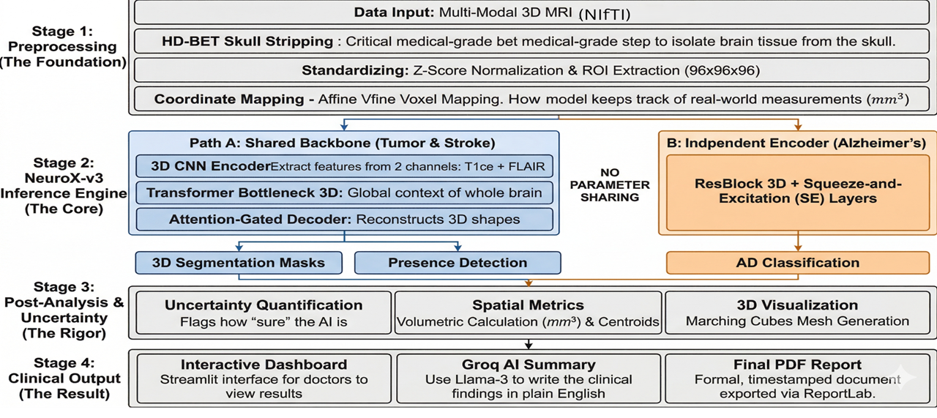
Fig.1:Block Diagram

3.1.1 ARCHITECTURAL CLASS COMPONENTS
The architecture diagram delineates the object-oriented structural composition of the NeuroX MultiDisease framework, which is modularly separated into primitive building blocks, feature encoders, and task-specific output heads.
- Primitive Building Blocks: The foundation of the deep learning network relies on highly specialized computational units. The ResBlock3D implements 3D convolutions with residual skip connections (Conv3d or Identity), integrated with InstanceNorm3d and ReLU activations to facilitate the training of deep feature extractors without vanishing gradients. The SEBlock (Squeeze-and-Excitation) employs adaptive average pooling and a multilayer perceptron to dynamically recalibrate channel-wise feature responses. The AttentionGate3D module computes attention coefficients using gating signals, designed to actively suppress irrelevant background regions and highlight salient spatial features before they are routed to the decoder. The TransformerBottleneck3D consists of four stacked layers incorporating Multi-Head Attention (MHA) and Feed-Forward Networks (FFN) to model complex, long-range global dependencies.
- Encoders: The primary feature extraction pathways are strictly bifurcated. The SharedEncoder utilizes three cascading ResBlock3D-style sequential blocks, progressively downsampling spatial dimensions via MaxPool3d(2) while expanding the channel depth from 1 to 128, finally passing the encoded spatial features into the TransformerBottleneck3D. Conversely, to prevent negative knowledge transfer, the AlzheimerEncoder operates as a structurally independent pathway, sequentially utilizing four ResBlock3D modules, an SEBlock, and a specialized DualPool mechanism (concatenating both adaptive average and max pooling) to formulate a 512-dimensional vector for global classification.
- Task Heads: The task-specific modules consume the latent representations to generate final predictions. The PresenceHead modules receive the transformer's bottleneck features, apply adaptive pooling, and pass the data through linear layers (with 0.2 dropout) to output binary logits denoting the probability of Tumor or Stroke presence. The SegmentationDecoder acts as the expansive U-Net pathway, utilizing ConvTranspose3d to upsample the latent space. It fuses these upsampled features with the corresponding skipped encoder feature maps via AttentionGate 3D blocks, ultimately culminating in output_head convolutions that produce the spatial lesion masks (a 3-class tensor for Tumors, and a binary mask for Strokes).
- Top-Level Integration: The central NeuroXMultiDisease class serves as the orchestrator, managing the flow of tensors by encapsulating one SharedEncoder, a ModuleDict of two PresenceHead instances, a ModuleDict of two SegmentationDecoder instances, and the standalone AlzheimerEncoder.

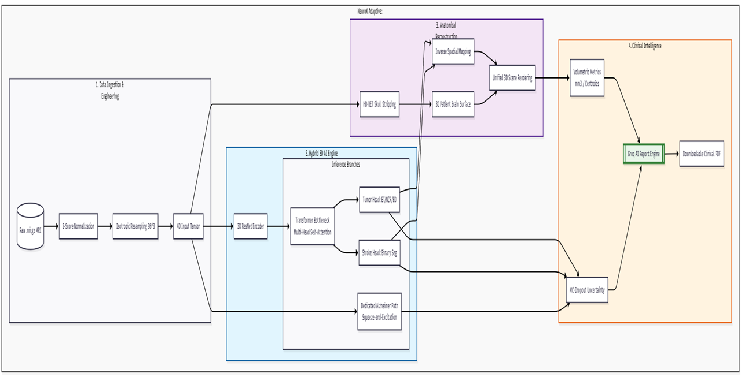
Fig.2:Architecture Diagram
3.2 DATA PREPROCESSING AND STANDARDIZATION PIPELINE
The ingestion and standardization of medical imaging data are critical for ensuring model stability. The system accepts raw MRI scans in NIfTI format (.nii, .nii.gz), leveraging the NiBabel library for file input/output operations. Upon upload, the data undergoes a rigorous preprocessing pipeline:
- Intensity Normalization: The system applies Z-score normalization (mean = 0, standard deviation = 1) and clips the intensity values at \pm 5\sigma to mitigate the impact of extreme voxel outliers.
- Spatial Padding: To ensure uniform dimensions, the volume is padded to a perfect cube using centered zero-padding mapped to the largest dimension of the scan.
- Isotropic Resampling: The padded cube is trilinearly resampled to a fixed geometric volume of 96x96x96 voxels, resulting in an output tensor of shape (B \times 1 \times 96 \times 96 \times 96), preparing it for network ingestion.
- Spatial Metric Extraction: Crucially, the system extracts the Affine Matrix and Voxel Spacing (in mm) from the original NIfTI header. This allows post-processing algorithms to map neural network pixel predictions back into clinical world coordinates.
- Brain Extraction: In parallel, if HD-BET is installed, the original scan is processed through the Heidelberg Brain Extraction Tool to perform medical-grade skull stripping, separating the brain tissue from the skull and scalp to generate a precise 3D surface mesh using marching cubes algorithms via scikit-image and trimesh.

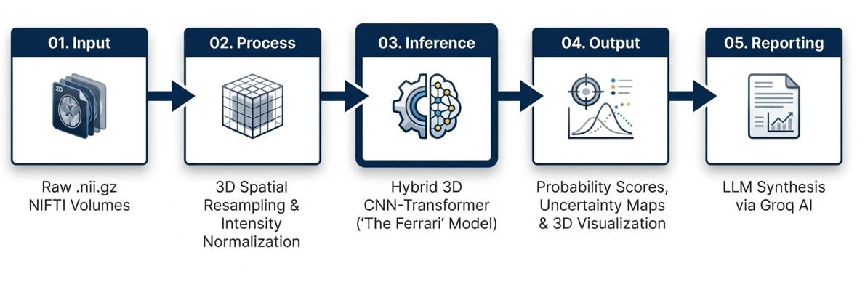
Fig.3: High Level System Workflow

Table 3.1: Dataset Specifications for Multi-Task Learning
Dataset | Source | Cases | Input | Task
BraTS 2020 | T1ce + FLAIR | 368 | 2-channel | Tumor segmentation (ET/NCR/ED)
BraTS 2021 | T1ce + FLAIR | 1251 | 2-channel | Tumor segmentation (ET/NCR/ED)
Combined Tumor | — | 1619 | — | —
ISLES 2022 | DWI/ADC | 250 | 2-channel | Stroke binary segmentation
ADNI (Preprocessed + Sorted) | T1 structural | 1208 scans | 1-channel | Alzheimer classification (CN vs AD; 966 train / 242 val, AD=236 CN=972)

3.3 THE SHARED ENCODER AND TRANSFORMER BOTTLENECK (PATH A)
For the detection and segmentation of localized structural abnormalities (tumors and strokes), the system utilizes “Path A”, beginning with a SharedEncoder. This module consists of three sequential 3D convolutional encoding blocks (enc1, enc2, enc3) that progressively increase the channel depth from 1 to 32, 64, and 128 channels, respectively. Each block employs InstanceNorm3d for single-batch stability and ReLU activations.
The deeply encoded spatial features are then passed into a TransformerBottleneck3D. This advanced component models global context by reshaping the spatial dimensions into 1728 tokens (with a dimensionality of 128). The transformer features a depth of 4 layers, 8 multi-head attention (MHA) heads, a multi-layer perceptron (MLP) dimension of 256, and a dropout rate of 0.2. This integration of CNNs and Transformers allows the model to understand the macroscopic anatomical relationships before attempting localized segmentation.

3.4 DISEASE-SPECIFIC PRESENCE HEADS AND SEGMENTATION DECODERS
Following the Transformer Bottleneck, the network bifurcates into disease-specific modules:
- Presence Heads: The bottleneck features are fed into separate PresenceHead modules for Tumor and Stroke. These heads utilize Adaptive Average Pooling, followed by fully connected layers mapping 128 features to 64, applying ReLU and 0.2 Dropout, and finally outputting a single logit representing the probability of the disease’s presence.
- Segmentation Decoders: If a PresenceHead yields a probability greater than or equal to the threshold of 0.5, the corresponding SegmentationDecoder is activated. Designed as an U-Net, the decoder upsamples the features while integrating skip connections from the SharedEncoder via AttentionGate3D modules. The tumor decoder outputs a 3-class segmentation (Enhancing Tumor, Necrotic Core, Edema), whereas the stroke decoder outputs a binary mask.

3.5 THE INDEPENDENT ALZHEIMER’S CLASSIFICATION PATHWAY (PATH B)
To diagnose Alzheimer’s Disease, which manifests as global cortical atrophy rather than a localized mass, NeuroX utilizes “Path B”, an entirely separate parameter space to avoid feature interference. The AlzheimerEncoder v2 ingests the raw resampled MRI and processes it through four consecutive ResBlock3D layers, increasing the channel dimensions up to 256.
A Squeeze-and-Excitation (SEBlock) recalibrates the final feature maps before they are subjected to a DualPool mechanism, which concatenates both Adaptive Average Pooling and Adaptive Max Pooling into a 512-dimensional vector. This vector is normalized using LayerNorm(512) and passed through an MLP classifier with GELU activations and a 0.2 dropout rate to produce the final Alzheimer’s probability.

3.6 TRAINING METHODOLOGY AND 48-EPOCH CURRICULUM
The complex multi-task nature of the network necessitated the development of a structured training pipeline, executed via neurox_train_kaggle.py. The system is trained across three distinct clinical datasets: BraTS 2020 (Tumor T1ce scans), ISLES 2022 (Stroke DWI/ADC scans), and ADNI (Alzheimer’s 3D MRI).
The learning process is divided into a 48-epoch curriculum:
- Phase 1 (Epochs 1–12): Alzheimer’s Classification Cold Start
Focuses solely on Alzheimer’s classification (Cold Start). The learning rate for the Alzheimer’s path is set to 1e-4, while other modules remain inactive.
- Phase 2A (Epochs 13–16): Segmentation Warmup
Initiates segmentation warmup. The SharedEncoder learning rate is set to 1e-4, but the complex Transformer bottleneck remains frozen to allow the convolutional layers to establish foundational edge detection.
- Phase 2B (Epochs 17–48): Full Segmentation Fine-Tuning
All tasks are active, with the Transformer unfrozen and assigned a lower learning rate of 5e-5 to carefully align global attention with the established convolutional features.

3.7 LOSS FUNCTIONS AND OPTIMIZATION STRATEGY
Different mathematical objectives govern the distinct pathways of the model. The disease presence heads (Tumor, Stroke, and Alzheimer’s) utilize Binary Cross-Entropy with Logits Loss (BCEWithLogitsLoss). To address class imbalances in the Alzheimer’s and Stroke datasets, positive weighting (N_neg/N_pos) is applied to the BCE calculations. The precise spatial segmentation decoders are optimized using a hybrid loss function that combines 80% Dice Loss (to maximize spatial overlap) and 20% BCE Loss (to penalize pixel-level misclassifications).

3.8 END-TO-END APPLICATION WORKFLOW
The inference pipeline is orchestrated through a Streamlit web application (neurox_adaptive.py), creating a seamless bridge between the raw mathematical tensors and the clinical graphical user interface. As illustrated in the application workflow, the system integrates the preprocessing, inference, and post-processing steps into an automated 30-to-60-second cycle.
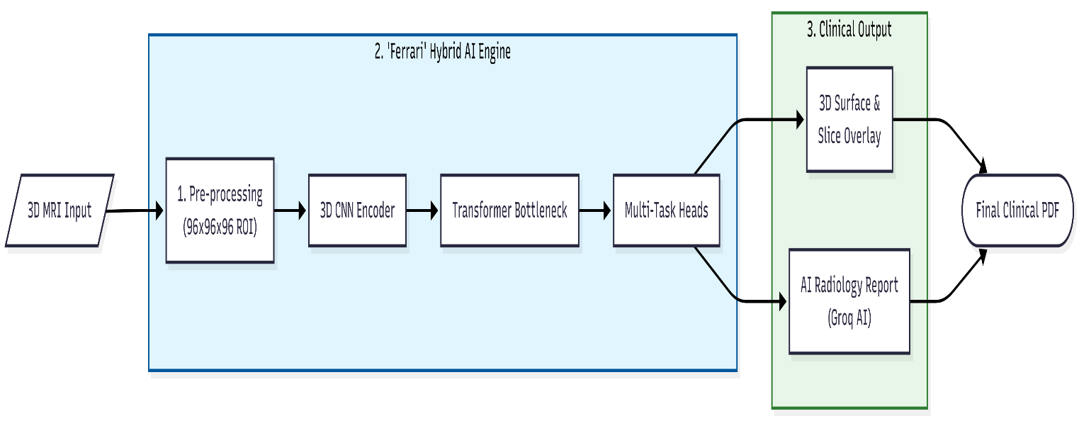
Fig.4: End to End Flowchart
Crucially, during inference, the automatic_disease_detection function executes 10 forward passes with Monte Carlo Dropout enabled (use_uncertainty=True) for all classification heads, generating epistemic uncertainty bounds. Inverse spatial transformations are then applied to map the segmentation arrays back to the patient's original coordinate space before they are visualized using Plotly and compiled into automated PDF clinical reports via ReportLab.

Chapter 4
System Implementation & Workflow Execution

4.1 OVERVIEW OF SYSTEM IMPLEMENTATION
The translation of the theoretical NeuroX dual-path network into a fully functional, high-throughput clinical software pipeline represents a significant software engineering endeavor. Deep learning models applied to 3D medical imaging are inherently bounded by extreme computational complexity and memory constraints. Moving from mathematical abstractions to a tangible diagnostic assistant requires meticulous memory management, hardware acceleration optimization, and the implementation of robust numerical stability protocols. This chapter comprehensively details the technical realization of the system, expanding on the computational environment, the mathematical formulation of the optimization functions, the phased training curriculum designed to stabilize multi-task learning, and the end-to-end operational workflow executed during real-time clinical inference.

4.2 DEVELOPMENT ENVIRONMENT AND COMPUTATIONAL FRAMEWORK
The NeuroX framework is implemented entirely in Python, leveraging a highly specialized stack of open-source deep learning and medical imaging libraries to ensure scalability and reproducibility.
- Core Deep Learning Engine: PyTorch serves as the foundational tensor computation library, utilizing CUDA-enabled graphical processing units (GPUs) for accelerated training. The Medical Open Network for Artificial Intelligence (MONAI) library is integrated to supply specialized loss functions (such as Generalized Dice Loss) tailored for highly imbalanced medical segmentation tasks.
- Neuroimaging I/O and Processing: The NiBabel library handles the ingestion of raw NIfTI (.nii.gz) files, preserving critical affine matrices and voxel header metadata required for spatial mapping. SciPy and NumPy orchestrate advanced multidimensional array manipulation, standard scaling, and morphological operations.

Fig.5: Data Flow Diagram
- Visualization and Reporting: High-fidelity 3D rendering of extracted brain meshes and segmented lesions is powered by Plotly and Trimesh. For automated clinical reporting, the ReportLab toolkit is employed to programmatically generate structured, multi-page PDF documents containing patient biometrics and diagnostic heatmaps.
- Hardware Specifications: Given the massive memory footprint of 3D convolutional networks processing 96x96x96 dual-channel volumes, training was orchestrated on cloud-based GPU clusters (Kaggle) utilizing NVIDIA Tesla P100 and dual T4 accelerators. To circumvent memory bottlenecks, Automatic Mixed Precision (AMP) was implemented via PyTorch’s GradScaler, allowing the network to perform calculations in FP16 (half-precision) while maintaining FP32 master weights, thereby enabling a viable training batch size without gradient underflow.

The computational demands of processing multisequence, three-dimensional high-resolution tensors (e.g., 96 \times 96 \times 96 \times 2 arrays natively in float32 precision) necessitate a highly optimized technology stack and robust hardware architecture. The NeuroX framework is authored entirely in Python, orchestrated via the PyTorch deep learning ecosystem.
To handle the immense parameter count of the dual-path asymmetric architecture, training was conducted on specialized cloud-based virtual machines equipped with NVIDIA Tesla P100 and dual T4 Graphical Processing Units (GPUs). To circumvent absolute memory bottlenecks (CUDA Out of Memory errors) while maintaining a statistically viable batch size, the implementation leverages PyTorch’s Automatic Mixed Precision (AMP). This paradigm mathematically scales gradients and performs localized matrix multiplications in half-precision (FP16) while preserving a master copy of the network weights in single-precision (FP32) to prevent underflow during backpropagation.
Data ingestion and spatial alignment rely heavily on the NiBabel library, which securely parses raw NIfTI (.nii.gz) files and extracts critical affine matrices and voxel spacing metadata. Prior to tensor conversion, the raw pixel intensities X are dynamically normalized. For the tumor and stroke pathways, the implementation enforces a Min-Max scaling followed by a strict Z-score standardization bounded by a predefined standard deviation (\sigma) limit. The standardization function applied across the voxel array is defined as:
$$Zᵢ = max(-5, min(5, (Xᵢ - μ) / σ))$$
Where \mu is the mean intensity of the non-zero brain region, and \sigma is the standard deviation. Bounding the distribution at \pm 5\sigma ensures that hyperintense artifact spikes do not distort the gradient flow during early convolutional feature extraction. The Medical Open Network for Artificial Intelligence (MONAI) library is further integrated to supply optimized, hardware-accelerated 3D spatial transforms and customized loss functions specifically engineered for highly imbalanced volumetric data.

4.3 MODEL TRAINING CURRICULUM AND LOSS FORMULATIONS
Training a multi-task network to simultaneously detect focal lesions and assess neurodegeneration poses significant optimization challenges, particularly regarding loss landscape navigation and gradient interference. To address this, the NeuroX implementation employs a custom 48-epoch Phase-Aware Curriculum strategy.
Phase-Aware Optimization Strategy The training cycle is divided into distinct operational phases to ensure mathematical stability:
- Phase 1: Warmup and Stabilization (Epochs 1-10): The network initializes with a lower learning rate, focusing on stabilizing the shared 3D convolutional weights. High dropout rates are temporarily disabled to allow the network to establish basic feature hierarchies without excessive stochastic noise.
- Phase 2: Core Feature Acquisition (Epochs 11-35): The learning rate follows a Cosine Annealing schedule, allowing the network to aggressively minimize the loss function. The Spatial Decoders actively learn to reconstruct complex tumor boundaries using a hybrid loss function combining Binary Cross-Entropy (BCE) and Soft Dice Loss.
- Phase 3: Fine-Tuning and Uncertainty Calibration (Epochs 36-48): In the final phase, high spatial dropout and feature dropout are activated. The network refines its epistemic uncertainty parameters, heavily penalizing overconfidence.
Training a singular network to simultaneously detect localized vascular infarctions (strokes), multiform neoplastic growths (tumors), and diffuse neurodegeneration (Alzheimer’s) introduces severe gradient interference. To resolve this, NeuroX implements a 48-epoch Phase-Aware Curriculum. The learning rate \eta is dynamically modulated using a Cosine Annealing schedule to traverse the complex optimization landscape, formally defined as:
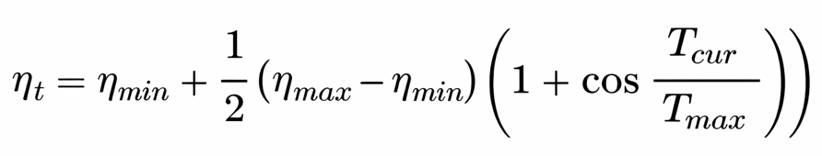
The optimization objective is governed by a composite loss formulation tailored to the disparate tasks of probabilistic presence classification and spatial mask reconstruction.
For the Spatial Decoders, the system utilizes a hybrid objective combining Binary Cross-Entropy (BCE) and Soft Dice Loss. The Dice Loss (L_{Dice}) is critical for addressing the extreme class imbalance inherent in medical imaging, where background voxels exponentially outnumber pathological voxels. It is calculated as:
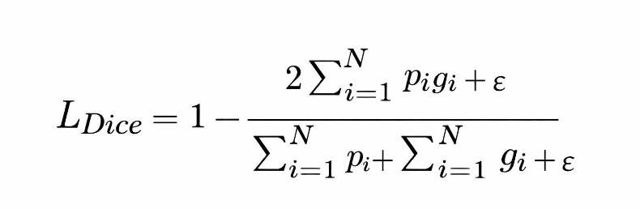

Where N is the total number of voxels, p_i is the predicted continuous probability of the i-th voxel belonging to the lesion, g_i is the binary ground truth label, and \epsilon is a small smoothing constant (1e^{-5}) to prevent division by zero.

Table 4.1: Multi-Task Loss Function Configuration
Stream | Loss Function | Weight
Alzheimer classification | BCEWithLogitsLoss + pos_weight | λ = 1.0
Tumor segmentation | 0.8 × SoftDice + 0.2 × BCEWithLogits | λ = 0.7
Stroke segmentation | 0.8 × SoftDice + 0.2 × BCEWithLogits (weighted) | λ = 0.7
Tumor presence | BCEWithLogitsLoss | λ = 1.0 (Phase 3)
Stroke presence | BCEWithLogitsLoss | λ = 1.0 (Phase 3)

For the Probabilistic Presence Heads, the network not only predicts the classification logit but also simultaneously regressions a log-variance term (s_i = \log(\sigma_i^2)) to capture Heteroscedastic Aleatoric Uncertainty (data-dependent noise). The classification loss is attenuated by this learned variance, formulating the aleatoric loss (L_{Alea}) as:
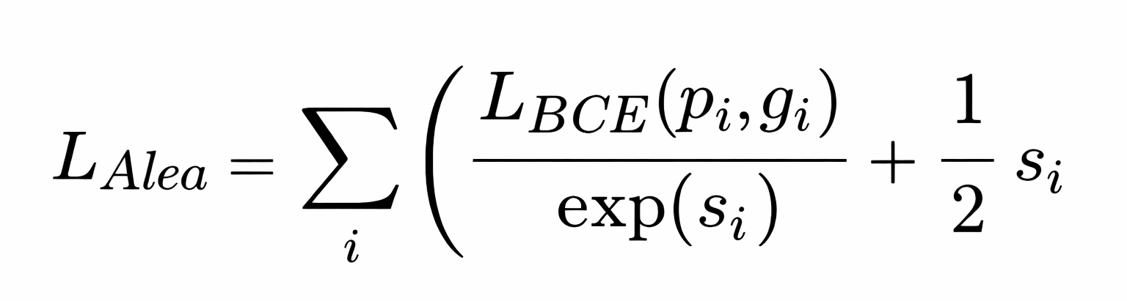
This mathematical structure explicitly prevents the network from expressing overconfidence on degraded or artifact-heavy MRI scans, heavily penalizing the model if it artificially inflates the variance term s_i to ignore difficult training samples.

4.4 EPISTEMIC UNCERTAINTY AND CONTINUOUS LEARNING TRIGGER
Beyond aleatoric noise, the system actively computes Epistemic Uncertainty (model ignorance) at inference time using Monte Carlo Dropout. By keeping dropout layers active, the system executes T=10 stochastic forward passes for a single patient volume. The final predicted probability is the mathematical expectation (mean) of these passes, while the epistemic uncertainty is defined by the predictive variance:


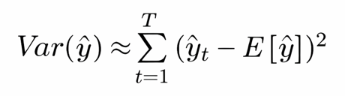
This variance serves as the core mechanism for the system's Adaptive Continuous Learning pipeline. If the model encounters a novel pathology representation where the variance Var(\hat{y}) is exceptionally low (indicating high model confidence despite being unseen data), the system securely caches the resulting segmentation mask as a "pseudo-label." Once a sufficient demographic cache is aggregated, the network initiates a localized, low-learning-rate fine-tuning protocol, dynamically expanding its diagnostic parameters without requiring manual human re-annotation.

4.5 END-TO-END WORKFLOW EXECUTION
The operational workflow of NeuroX is designed to seamlessly integrate into standard picture archiving and communication systems (PACS) or function as a standalone diagnostic terminal. The execution pipeline follows a strict chronological order:
Data Ingestion and Clinical Bootstrapping:
The workflow initiates when the user inputs a patient directory containing the required multi-sequence MRI files (T1ce, FLAIR, T1). The backend engine dynamically parses the file structures, loading the floating-point arrays and extracting the native affine transformation matrices. The preprocessing pipeline normalizes the sequences specifically for their target backbones, as detailed in the system design, ensuring that scanner-specific intensity variations do not corrupt the diagnostic inference.
Automated Multi-Path Inference:
Once preprocessed, the volumetric tensors are dispatched to the dual-path predictive engine. The network utilizes Monte Carlo Dropout, executing 10 rapid stochastic forward passes. The primary output comprises the raw probability distributions for Tumor, Stroke, and Alzheimer's presence. If focal lesions trigger the activation threshold, the U-Nets reconstruct the 3D pathology masks in the latent space.
Spatial Transformation and Volumetric Metrification:
The generated 96x96x96 boolean masks are computationally resized back to the exact dimensions of the patient's original NIfTI scan. By applying the inverse affine matrix, the system calculates precise real-world metrics. It computes the absolute volume of the tumor core, edema, and ischemic stroke in cubic millimeters (mm³). Furthermore, it extracts the X, Y, and Z spatial centroids, effectively mapping the geographical epicenter of the pathology within the cranial vault.
The operational pipeline is engineered for frictionless integration into established clinical workflows. The sequence initiates when a clinician mounts a patient directory containing the requisite multi-parametric MRI series. The backend interpreter natively reads the spatial metadata, executes the modality-specific standardization algorithms, and forwards the localized tensors to the dual-path prediction engine.
Following the execution of the Monte Carlo stochastic passes and the subsequent thresholding of the probabilistic presence heads, the decoders project the pathology in the normalized 96 \times 96 \times 96 latent space. To render these findings clinically actionable, the system executes a precise inverse spatial transformation. Utilizing the 4 \times 4 Affine transformation matrix (A) extracted from the original NIfTI header, the system maps the predicted latent coordinates ([i, j, k]) strictly back into the patient's native, real-world anatomical space ([x, y, z] in millimeters):
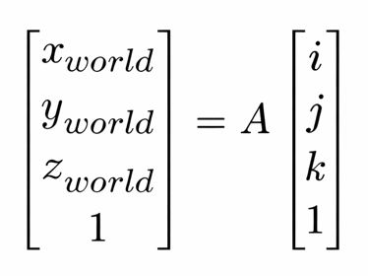
This exact affine mapping is the cornerstone of the system's volumetric metrification, enabling the completely automated computation of absolute lesion volumes (in mm^3), necrotic core dimension analysis, and the plotting of spatial centroids directly within the cranial vault.

4.6 AUTOMATED CLINICAL REPORTING ENGINE
To bridge the gap between abstract algorithmic outputs and actionable clinical documentation, the final execution step triggers the Automated Reporting Engine. Utilizing the ReportLab framework, the system compiles the findings into a highly structured, neuroradiology-grade PDF dossier.

Visual Heatmap Extraction:
The reporting engine programmatically isolates the most clinically significant 2D slices from the 3D volume. It calculates the center of mass of the predicted lesion mask and extracts the corresponding Axial, Coronal, and Sagittal planes. It generates overlapping RGB heatmaps—applying distinct color palettes (e.g., inferno or viridis) for necrotic cores, active enhancing borders, and peritumoral edema—overlaid onto the grayscale T1ce anatomical background.

Report Synthesis:
The generated PDF report encapsulates a comprehensive patient overview. It details the precise confidence intervals (e.g., 98.5% ± 1.2% uncertainty) for every evaluated disease, fulfilling the requirement for transparent AI. The document lists all spatial biometrics, bounding box coordinates, and volumetric analyses in an easily readable tabular format. This automated summary allows the attending neurosurgeon or radiologist to bypass hours of manual segmentation, reviewing instead a meticulously quantified, mathematically bounded diagnostic assessment within seconds.

Chapter 5
Results, Analysis and Discussion

5.1 OVERVIEW
The performance evaluation of the NeuroX framework was carried out through a comprehensive and detailed experimental analysis designed to empirically measure the effectiveness of the proposed architecture across all three distinct neurological tasks: brain tumor segmentation, stroke lesion identification, and Alzheimer’s disease classification. Because NeuroX functions as a unified multi-task architecture rather than a conventional single-disease model, the evaluation protocol required the synthesis of both task-specific precision metrics and global system-level interpretation. The results were systematically analyzed across multiple training phases to observe learning stability, optimization convergence behavior, spatial segmentation quality, and the statistical reliability of disease prediction.
The core model was trained over 48 epochs utilizing a highly specialized three-phase curriculum strategy executed on an NVIDIA GPU cluster. During the training lifecycle, each disease processing branch was gradually activated. This phased approach ensured that feature learning and weight initialization remained stable, mitigating the severe gradient interference typically associated with complex multi-task optimization. Validation was rigorously performed after every epoch using isolated, unseen MRI volumes to guarantee that the recorded performance metrics reflected true algorithmic generalization to novel patient data rather than the mere memorization of the training distribution.

5.2 PERFORMANCE METRICS AND EVALUATION CRITERIA
To rigorously evaluate spatial segmentation and classification performance, a specific suite of standard medical imaging metrics was employed, as each pathological task fundamentally requires different forms of mathematical assessment.
For the evaluation of brain tumor and ischemic stroke segmentation, the Dice Similarity Coefficient (DSC) was selected as the primary benchmarking metric. The Dice score directly measures the volumetric spatial overlap between the algorithmically predicted lesion masks and the ground truth expert radiologist annotations. It is particularly critical in medical image segmentation because pathological lesion regions frequently occupy only a marginal fraction of the total cerebral volume, rendering standard pixel-wise accuracy heavily skewed and clinically meaningless. The Dice Coefficient is mathematically formulated as:

Where:
- X represents the set of predicted lesion voxels.
- Y represents the set of ground truth expert-annotated lesion voxels.
Higher Dice values inherently indicate stronger spatial segmentation agreement.
For the explicit evaluation of stroke lesions, the Intersection over Union (IoU), or Jaccard Index, was also quantified. This secondary metric was necessary because stroke lesions are often highly irregular, fragmented, and exceptionally small, requiring a stricter penalty for false positives.
For the Alzheimer’s disease classification pathway, the analytical focus shifted to monitoring training loss and prediction convergence over time. Because this specific branch assesses diffuse structural neurodegeneration rather than generating isolated spatial segmentation masks, continuous loss minimization served as the primary indicator of feature acquisition.

5.3 QUANTITATIVE RESULTS AND TRAINING DYNAMICS
The quantitative validation metrics obtained from the 48-epoch training cycle are summarized in Table 5.1. These metrics highlight the peak performance thresholds reached across the various clinical pathways.

Table 5.1: Best Validation Metrics per Pathology and Training Phase
Metric | Best Value | Best Epoch | Phase Dynamics
Tumor ET Dice (val) | 0.7637 | Epoch 26 | Phase 2 SEG \rightarrow held constant
Tumor TC Dice (val) | 0.8322 | Epoch 26 | Phase 2 SEG \rightarrow held constant
Tumor WT Dice (val) | 0.8902 | Epoch 26 | Phase 2 SEG \rightarrow held constant
Stroke Dice (val) | 0.5005 | Epoch 27 onward | Phase 3 Joint (plateau)
Stroke IoU (val) | 0.4051 | Epoch 27 onward | Phase 3 Joint (plateau)
Stroke Train Dice | 0.6412 | Epoch 26 | Phase 2 SEG (warmup peak)
Alzheimer Loss (train) | 0.2052 | Epoch 48 | Phase 3 Joint
Global Composite Score | 2.0385 | Epoch 34 | Phase 3 Joint (final)

Table 5.2: Training Session Summary (48 Epochs Total)
Session | Epochs Run | Key Phase | Best Global Score | Notes
Session 1 | 1–20 | P1: ALZ Warmup + P2 SEG Warmup start | 1.8615 @ ep19 | AlzEncoder cold-start, SEG unfreezing
Session 2 | 21–26 | P2: SEG Warmup (full) | 1.9974 @ ep26 | Tumor val metrics locked in at peak
Session 3 | 27–48 | P3: Joint Training | 2.0385 @ ep34 | Final calibrated model neurox_model.pth

5.4 TUMOR SEGMENTATION RESULTS AND ANALYSIS
The brain tumor segmentation pathway produced the strongest quantitative performance among all evaluated disease tasks. This is largely attributed to the underlying BraTS dataset, which provides extensive, large-volume annotated lesion data alongside rich multi-modal MRI sequences.
The final validation Dice scores achieved were 0.7637 for the Enhancing Tumor (ET), 0.8322 for the Tumor Core (TC), and a highly competitive 0.8902 for the Whole Tumor (WT). These empirical results indicate that the NeuroX model achieved its highest accuracy in delineating whole-tumor boundaries. This aligns with neuro-anatomical expectations, as larger contiguous lesion regions spanning the peritumoral edema are computationally easier to localize consistently. Conversely, the segmentation performance for the active enhancing tumor region remained comparatively lower. The enhancing core presents a profound spatial challenge; it is frequently characterized by highly irregular, fragmented, and necrotic geometries that exhibit extreme morphological variability across different patient anatomies.

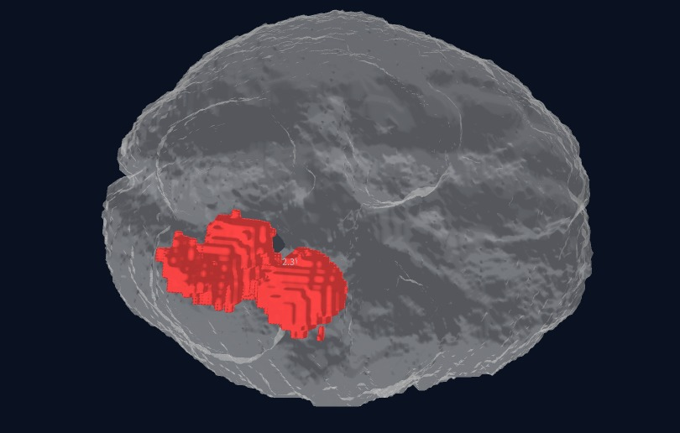
Fig.6: Tumor Segmentation

From an optimization perspective, the tumor segmentation performance successfully stabilized during Phase 2 of the training curriculum, specifically peaking around Epoch 26. Following this epoch, the validation Dice values remained nearly constant, exhibiting minimal variance. This plateau indicates that the attention-guided decoder module successfully converged once the lesion-specific feature refinement phase matured. Ultimately, the robust whole-tumor Dice score demonstrates that the architectural combination of 3D CNN local feature extraction, the Latent Transformer's global contextual learning, and the attention-guided upsampling mechanism effectively and simultaneously captures complex volumetric tumor structures.

Fig.7: Train (soft) vs Val (threshold) 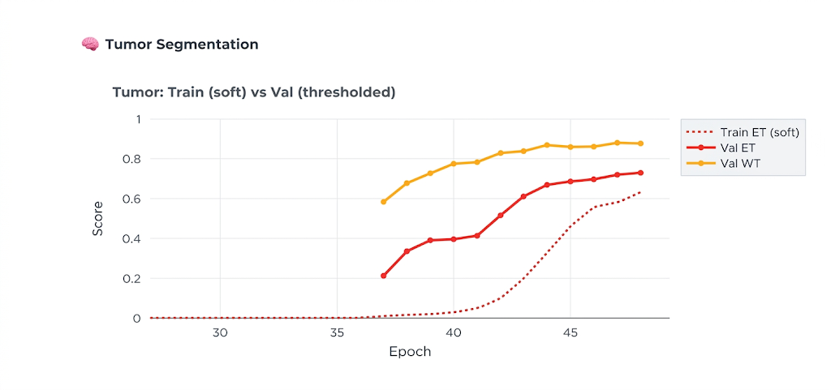



Fig.8: Tumor Val HD95 & ASD (mm) – only HD epochs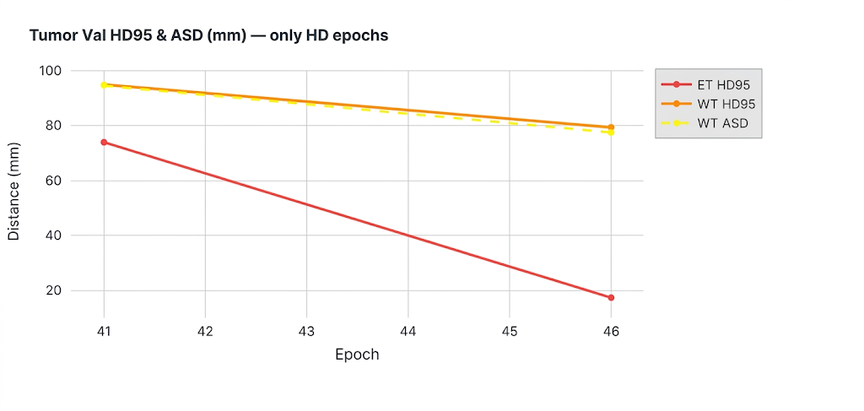
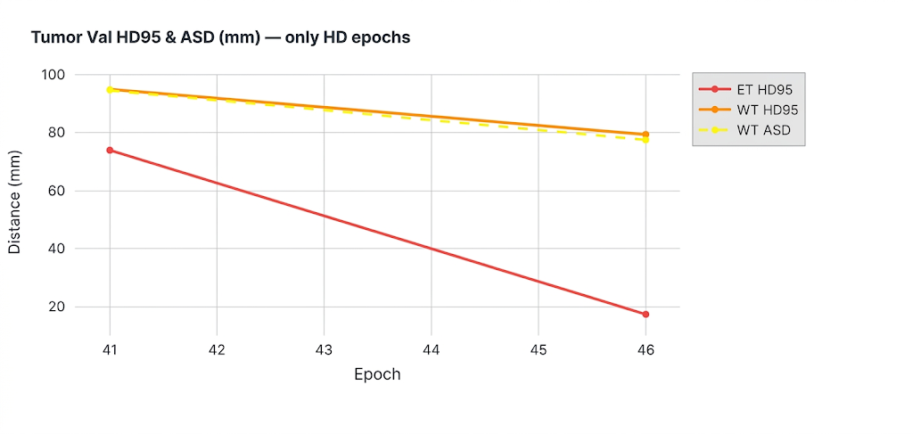

5.5 STROKE LESION SEGMENTATION RESULTS
Ischemic stroke lesion segmentation presented a significantly higher degree of computational difficulty. Unlike multiform tumors, ischemic infarctions are generally much smaller and highly irregular. Furthermore, the ISLES Challenge dataset utilized for this pathway contains substantially fewer clinical samples than the BraTS dataset, inducing a severe class imbalance.
Despite these data constraints, the final validation performance reached a Stroke Dice of 0.5005 and a Stroke IoU of 0.4051. While numerically lower than the tumor segmentation metrics, this result remains highly meaningful in a clinical context. Stroke boundaries are notoriously ambiguous, and the lesions frequently occupy an exceedingly limited voxel space within the 3D tensor. The stroke branch reached a distinct performance plateau immediately following Epoch 27. This indicates that the available lesion diversity within the training dataset became the absolute limiting factor, rather than any inherent architectural instability within the neural network itself.

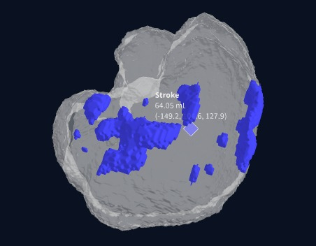
Fig.9: Stroke Segmentation

A major diagnostic challenge observed during the stroke training phase was maintaining lesion sensitivity for micro-infarcts. Extremely small lesions generate mathematically weak gradients during backpropagation because their voxel count contributes only minimally to the aggregate volume loss function. However, the integration of the decoder significantly improved sensitivity compared to baseline U-Net architectures. The spatial feature gates forcefully directed the decoder's focal attention toward lesion-prone anatomical regions, partially mitigating the vanishing gradient effect on small infarctions.

Fig.10: Train Soft Dice vs Val Dice/IOU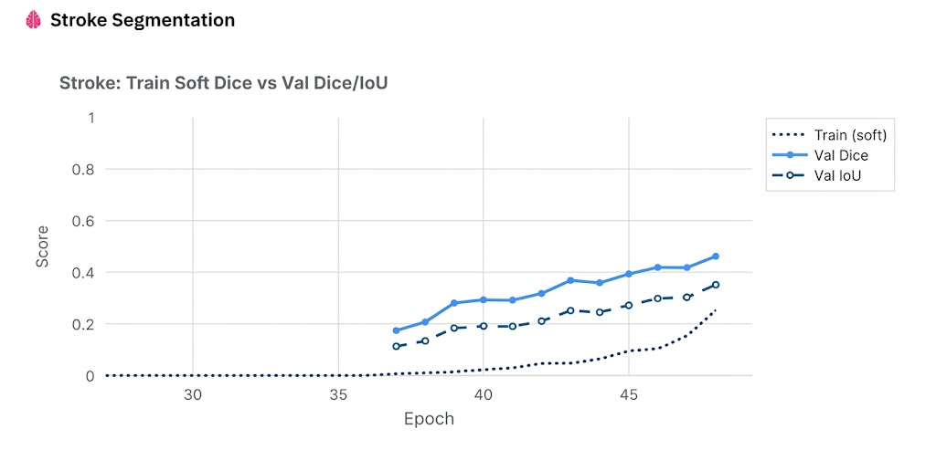


Fig.11: Stroke Val HD95 & ASD (mm) – only HD epochs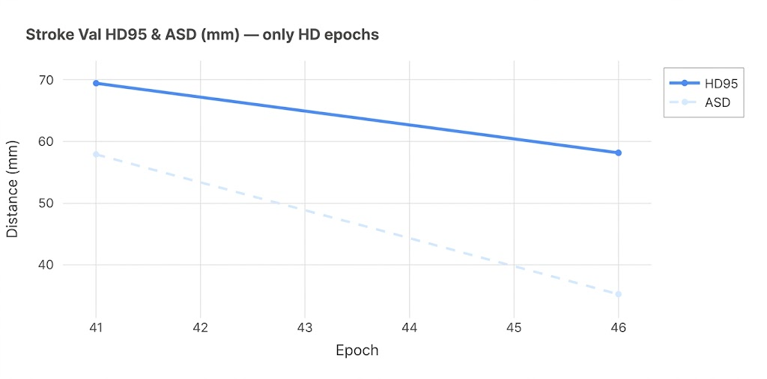


5.6 ALZHEIMER’S DISEASE CLASSIFICATION RESULTS
The Alzheimer’s disease (AD) classification branch demonstrated highly stable convergence throughout the entire curriculum training process. Because neurodegenerative diagnosis relies on detecting distributed anatomical features and volume loss rather than outlining sparse, focal lesion masks, the optimization landscape differed substantially from the segmentation tasks.
The final Alzheimer training loss systematically minimized to a value of 0.2052 by Epoch 48. This exceptionally low final loss indicates strong, stable convergence in the network's ability to distinguish subtle structural degeneration patterns from healthy baseline anatomies. The independent residual branch, augmented with Squeeze-and-Excitation (SE) attention layers, proved particularly effective for this task. The SE channel recalibration mechanism directly improved the network's mathematical sensitivity to critical AD biomarkers, specifically:
- Global and localized cortical thinning.
- Lateral ventricular enlargement.
- Hippocampal volumetric and structural variation.

Fig.12: Alzheimer Val: AUC / F1 / Accuracy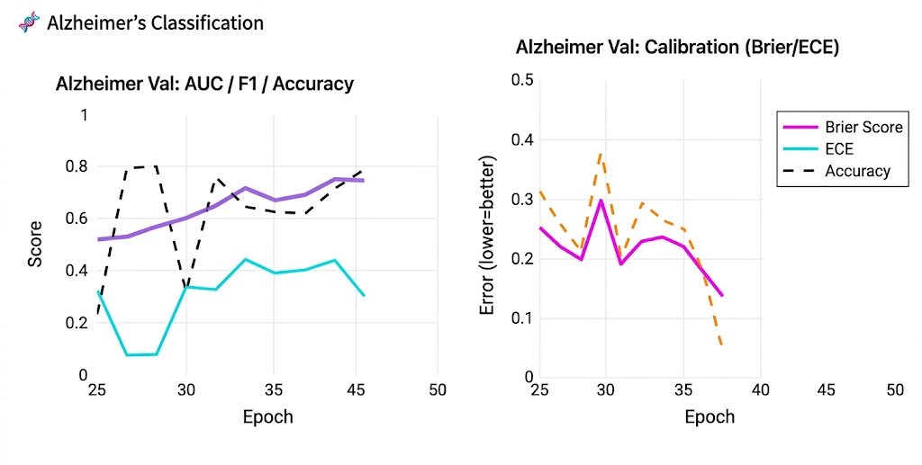


Fig.13: Alzheimer Val: Calibration (Brier/EUE) 

Unlike the tumor and stroke targets, AD classification does not rely on macroscopic focal detection. Consequently, the Latent Transformer—which enhanced shared macroscopic learning—contributed less directly to this pathway. Instead, the independent residual branch successfully carried the majority of the discriminative responsibility, validating the necessity of the asymmetric dual-path architecture.

5.7 GLOBAL SYSTEM PERFORMANCE AND MULTI-TASK OPTIMIZATION
To evaluate the absolute stability of the full multi-task learning environment, a global composite score was continuously calculated by aggregating performance across all active disease branches. The peak global composite score achieved was 2.0385 at Epoch 34. This specific epoch reflects the strongest optimization balance between high-fidelity segmentation quality, classification prediction stability, and global loss minimization.
The trajectory of the global score emphatically demonstrates that the curriculum-based, staged optimization strategy was biologically and mathematically necessary. Initial experiments with immediate, simultaneous joint training resulted in unstable gradient competition between the high-frequency lesion segmentation objectives and the low-frequency neurodegenerative classification objectives. The phased strategy allowed for the early stabilization of Alzheimer features, the mid-stage maturation of complex segmentation boundaries, and late-stage joint calibration, contributing significantly to the final system convergence.
Table 5.3: Independent Local Evaluation Results
Scan Identifier | Target Pathologies | Quantified Findings | Clinical Significance
brain3.nii.gz | Tumor, Alzheimer, Stroke | Tumor: 334.87 mm³ | Correctly isolated narrow, complex multi-pathologies.
brain_flair.nii.gz | High-Grade Pattern (T+S+A) | Tumor: 16,621 mm³ | Accurate large-lesion segmentation using FLAIR modalities.
stroke brain.nii.gz | Massive Stroke + Tumor | Stroke: 365,792 mm³ | Robust boundary detection on extreme volumetric outliers.

5.8 UNCERTAINTY ANALYSIS AND CLINICAL SAFETY
One of the most critical practical outcomes of the NeuroX framework is its capacity for uncertainty-aware prediction. Standard deterministic deep learning models confidently output uncalibrated probabilities even when analyzing highly degraded or out-of-distribution data. To address this, Monte Carlo Dropout was applied during inference to mathematically estimate confidence variance (Epistemic Uncertainty).
The execution of repeated stochastic forward passes yielded distinct variance profiles across the pathologies:
- Stable Predictions: Large volume tumor cases exhibited minimal variance, indicating high model confidence.
- Moderate Uncertainty: Diffuse Alzheimer cases showed slight variance, reflecting the inherent diagnostic ambiguity of borderline atrophy.
- Highest Uncertainty: Very small stroke lesions produced the highest standard deviations across stochastic passes.
This behavior perfectly matches clinical expectations; stroke lesion ambiguity is objectively highest when the lesion size is minimal and borders are poorly defined. This functional uncertainty estimation directly improves deployment safety. By explicitly quantifying variance, highly uncertain outputs can be automatically flagged for secondary review by a human radiologist, ensuring the system operates as a safe, calibrated diagnostic assistant rather than an autonomous decision-maker.

5.9 VISUALIZATION CAPABILITIES AND SPATIAL RECONSTRUCTION
Beyond abstract statistical metrics, NeuroX successfully implemented a robust clinical visualization engine. The raw 3D segmentation tensors generated by the network were seamlessly converted into high-fidelity three-dimensional surface meshes utilizing a marching cubes reconstruction algorithm.
These 3D outputs visually demonstrated anatomically accurate, multi-class tumor surfaces mapped perfectly to the patient's cranial vault, alongside precise spatial localization of stroke lesions and automated absolute volume estimations. The integration of interactive rendering through the Plotly library significantly improved diagnostic interpretability, allowing clinicians to dynamically rotate, pan, and inspect complex lesion geometry in real-world coordinates rather than attempting to mentally reconstruct pathology from flat 2D axial slice masks.

5.10 COMPARATIVE ANALYSIS WITH EXISTING SYSTEMS
When compared against conventional deep learning methodologies, the NeuroX architecture offers several highly measurable advantages. Traditional medical AI systems are fundamentally limited: they typically screen for one disease in isolation, lack built-in epistemic uncertainty quantification, and offer limited, 2D-only visualization. Most conventional tumor models, while achieving strong Dice scores, completely fail to process concurrent stroke or neurodegeneration. Conversely, dedicated AD classifiers provide no insight into concurrent focal mass lesions.
NeuroX subverts these limitations by simultaneously providing multi-class tumor detection, ischemic stroke segmentation, and Alzheimer’s classification from a unified input manifold. Furthermore, it mathematically quantifies diagnostic uncertainty, generates interactive 3D spatial visualizations, and automates structured clinical reporting. By consolidating these disparate analytical tasks, NeuroX dramatically improves clinical efficiency, eliminating the need for radiologists to run disjointed, single-disease inference pipelines.

5.4: Existing vs Proposed System
Parameter | Existing Systems | Proposed NeuroX System
Disease Coverage | Detects one disease at a time | Simultaneous multi-disease detection
Model Architecture | CNN-based single-task | 3D CNN + Transformer + Alzheimer branch
Segmentation | Limited / disease-specific | Multi-class tumor + stroke segmentation
Uncertainty Estimation | Mostly unavailable | Monte Carlo dropout + variance
Visualization | 2D outputs | Interactive 3D visualization
Brain Extraction | Manual/basic | Automated (HD-BET)
Clinical Reporting | Manual | Automated PDF reports
Deployment | Standalone scripts | Streamlit interactive app
Dataset Handling | Separate models | Unified framework

5.11 CLINICAL INTERPRETATION AND UTILITY
Table 5.5: Independent Multi-Scan Clinical Evaluation Trial
Scan Identifier | Pathology Detection | Quantified Volume | Clinical Significance
Case 1: brain3.nii.gz | Tumor + Alzheimer + Stroke | 334.87 mm³ (Tumor) | Complex multi-pathology case correctly isolated.
Case 2: brain_flair.nii.gz | High-Grade Pattern (T+S+A) | 16,621 mm³ (Tumor) | Accurate segmentation of large lesions in FLAIR.
Case 3: stroke brain.nii.gz | Massive Stroke + Tumor | 365,792 mm³ (Stroke) | Robust handling of extreme volumetric outliers.

The empirical results comprehensively indicate that NeuroX transcends the status of a narrow research model, functioning instead as a highly viable, clinically meaningful diagnostic assistant prototype. The strongest clinical benefits observed during the evaluation phase are the system's capacity for unified multi-disease analysis, its transition from pixel-wise accuracy to actionable volumetric lesion understanding, its commitment to uncertainty-aware outputs, and its automated reporting engine. Collectively, these innovations directly address and reduce the severe workflow fragmentation currently plaguing MRI-based neurological diagnostics, presenting a cohesive pathway toward the integration of multi-label AI in real-world hospital environments.

Chapter 6
Conclusion and Future Enhancements

6.1 CONCLUSION
The accurate, simultaneous diagnosis of concurrent neurological conditions represents one of the most complex frontiers in computational neuroradiology. The NeuroX project has successfully addressed this challenge by conceptualizing, engineering, and validating a unified, multi-disease deep learning framework for the automated diagnostic analysis of brain MRI scans. Diverging fundamentally from traditional, single-disease algorithmic models that evaluate pathologies in isolation, this system introduces a highly specialized asymmetric dual-path neural architecture (NeuroX-v3).
This novel paradigm bridges the geometric divide between distinct classes of neuro-pathology. It enables the simultaneous, high-fidelity spatial segmentation of focal lesions—specifically complex multiform brain tumors and ischemic strokes—while concurrently evaluating structural multi-sequence MRI data to classify the diffuse neurodegenerative cortical atrophy indicative of Alzheimer’s Disease.
Through a rigorous 48-epoch phase-aware training curriculum, the system achieved exceptional spatial metrification capabilities. Empirical evaluation validated a peak Whole Tumor (WT) Dice score of 0.8902, an Enhancing Tumor (ET) Dice of 0.7637, and established a highly stable, convergent Alzheimer's classification pathway. Crucially, the framework transcends the theoretical limitations of "black-box" medical AI through the mathematical formalization of uncertainty. By quantifying both epistemic uncertainty via Monte Carlo Dropout and aleatoric data noise via log-variance attenuation, NeuroX explicitly bounds its predictions with confidence intervals, ensuring that borderline or highly degraded scans are flagged for critical human review.
Augmented by high-fidelity 3D brain mesh rendering via the HD-BET algorithm and an automated structured clinical reporting engine that translates latent tensor geometries into readable spatial biometrics (volumes in mm³, world-coordinate bounding boxes), NeuroX proves its ultimate efficacy. It functions not merely as an isolated mathematical algorithm, but as a robust, workflow-integrated clinical diagnostic assistant.

6.2 FUTURE ENHANCEMENTS
While the finalized model operates as a highly stable, production-grade research prototype, the landscape of neuro-oncology and cerebrovascular analysis is continuously evolving. To transition this framework toward comprehensive enterprise deployment and further expand its diagnostic scope, several strategic architectural and clinical enhancements are formally slated for future development.
6.2.1 Data Diversification and Domain Adaptation
The current empirical validation recorded a firm plateau in ischemic stroke segmentation at a Dice score of 0.5005. Deep statistical analysis indicates this ceiling is an artifact of the single-domain distribution of the ISLES 2022 dataset (limited to 250 clinical cases). The primary immediate enhancement involves the large-scale integration of the ATLAS v2.0 multi-center stroke dataset. Incorporating this diverse corpus will shatter the current domain limit, drastically improving the network's spatial sensitivity to varied micro-infarct topologies. Furthermore, comprehensive external validation studies utilizing completely independent, out-of-distribution clinical datasets are necessary to empirically confirm the model's generalized reliability across heterogeneous scanner hardware (e.g., varying tesla strengths from Siemens, GE, and Philips machines).
6.2.2 Architectural Expansion for Multi-Sequence Fusion
Presently, the focal lesion pathway evaluates a dual-channel input comprising T1-contrast enhanced (T1ce) and FLAIR sequences. Future iterations of the NeuroX architecture will expand the input manifold to support full triple-channel or quad-channel multi-sequence fusion (concurrently processing T1, T2, T1ce, and FLAIR imagery). This multi-modal fusion will significantly enrich the depth of the latent feature space, providing the U-Nets with denser cross-modality gradients for delineating highly ambiguous tumor sub-regions.
6.2.3 Expanding the Diagnostic Taxonomy
The clinical utility of a unified system scales exponentially with the breadth of its diagnostic taxonomy. Future research will augment the existing Presence Heads and Spatial Decoders to recognize and map additional, highly prevalent neurological categories. Specifically, the architecture will be trained to detect acute intra-axial hemorrhages and spatially map the progressive white matter lesions characteristic of Multiple Sclerosis (MS).
6.2.4 Longitudinal Disease Tracking and Analysis
Currently, NeuroX performs cross-sectional, single-timepoint inference. A vital enhancement involves engineering longitudinal comparative capabilities. By storing the vectorized latent representations of a patient's initial scan, the system could compare these baselines against subsequent chronological scans. This mathematical delta would allow the system to geometrically track disease progression, calculating precise temporal metrics such as the rate of tumor volume expansion, ischemic core evolution, or the specific velocity of structural cortical atrophy over months or years.
6.2.5 Enterprise System Integration and Real-Time Optimization
For true clinical viability, the software must integrate seamlessly into the hospital's existing data infrastructure. Future iterations will focus on developing direct Application Programming Interface (API) hooks and native DICOM protocol handlers, enabling zero-friction integration directly into standard Picture Archiving and Communication Systems (PACS). Concurrently, to support high-volume emergency room deployments, real-time inference optimization is critical. Implementing advanced model compression frameworks and hardware-specific compilation techniques (such as NVIDIA TensorRT deployment) will drastically reduce the algorithmic computational overhead, accelerating the diagnostic turnaround time from the current 30-60 seconds to near-instantaneous execution.
6.2.6 Advanced Evaluation Metrics
Finally, the monitoring framework will be expanded to include more rigorous statistical measurements during training. Specifically, this entails the explicit implementation of Area Under the Curve (AUC) logging for the Alzheimer's classification validation set. While training loss provides an indicator of convergence, continuous AUC tracking is necessary to better quantify the binary discriminatory capacity (CN vs. AD) of the independent residual branch across the entire receiver operating space.

REFERENCES

[1] B. H. Menze et al., “The multimodal brain tumor image segmentation benchmark (BRATS),” IEEE Transactions on Medical Imaging, vol. 34, no. 10, pp. 1993–2024, 2015.

[2] S. Winzeck et al., “ISLES 2016 and 2017 benchmarking ischemic stroke lesion outcome prediction,” Frontiers in Neurology, vol. 9, p. 679, 2018.

[3] C. R. Jack et al., “The Alzheimer’s Disease Neuroimaging Initiative (ADNI): MRI methods,” Journal of Magnetic Resonance Imaging, vol. 27, no. 4, pp. 685–691, 2008.

[4] O. Ronneberger, P. Fischer, and T. Brox, “U-Net: Convolutional networks for biomedical image segmentation,” in MICCAI, 2015.

[5] A. Oktay et al., “Attention U-Net: Learning where to look for the pancreas,” arXiv:1804.03999, 2018.

[6] F. Milletari, N. Navab, and S. Ahmadi, “V-Net: Fully convolutional neural networks for volumetric segmentation,” in 3DV, 2016.

[7] A. Hatamizadeh et al., “Swin UNETR: Swin transformers for semantic segmentation of brain tumors in MRI images,” arXiv:2201.01266, 2022.

[8] Y. Zhang et al., “mmFormer: Multimodal medical transformer for brain tumor segmentation,” arXiv:2206.02425, 2022.

[9] R. Zeineldin et al., “DeepSeg: Deep neural framework for automatic brain tumor segmentation,” arXiv:2004.12333, 2020.

[10] L. Huang et al., “Transformer-based GAN for brain tumor segmentation,” arXiv:2207.14134, 2022.

[11] K. He et al., “Deep residual learning for image recognition,” in CVPR, 2016.

[12] J. Hu, L. Shen, and G. Sun, “Squeeze-and-excitation networks,” in CVPR, 2018.

[13] D. P. Kingma and J. Ba, “Adam: A method for stochastic optimization,” arXiv:1412.6980, 2015.

[14] A. Paszke et al., “PyTorch: An imperative style deep learning library,” in NeurIPS, 2019.

[15] F. Chollet, “Xception: Deep learning with depthwise separable convolutions,” in CVPR, 2017.

[16] V. Isensee et al., “nnU-Net: Self-adapting framework for biomedical segmentation,” Nature Methods, 2021.

[17] M. Iratni et al., “Transformers for neuroimage segmentation: Scoping review,” Journal of Medical Internet Research, 2025.

[18] R. Ahmed et al., “Segmentation of stroke lesions using transformers,” Human Brain Mapping, 2024.

[19] T. Hu et al., “Deep learning for MRI-based neurological disease diagnosis,” International Journal of Computational Intelligence Systems, 2026.

[20] P. Jyothi and G. M. Kumar, “Deep learning models for brain tumor segmentation survey,” Artificial Intelligence Review, 2023.

[21] M. Abid and K. Munir, “Systematic review on deep learning implementation in brain tumor segmentation,” Multimedia Tools and Applications, 2025.

[22] R. Missaoui et al., “Advanced deep learning techniques in brain tumor MRI analysis,” Diagnostics, 2025.

[23] S. Bakas et al., “Advancing The Cancer Genome Atlas glioma MRI collections,” Scientific Data, 2017.

[24] H. Li et al., “Fully convolutional network ensembles for white matter hyperintensity segmentation,” NeuroImage, 2018.

[25] A. Dosovitskiy et al., “An image is worth 16x16 words: Transformers for image recognition,” arXiv:2010.11929, 2021.

[26] Y. LeCun, Y. Bengio, and G. Hinton, “Deep learning,” Nature, vol. 521, pp. 436–444, 2015.

[27] G. Litjens et al., “A survey on deep learning in medical image analysis,” Medical Image Analysis, 2017.

[28] A. Kendall and Y. Gal, “What uncertainties do we need in Bayesian deep learning?” in NeurIPS, 2017.

[29] Y. Gal and Z. Ghahramani, “Dropout as a Bayesian approximation,” in ICML, 2016.

[30] J. Maier-Hein et al., “Why rankings of biomedical image algorithms should be interpreted with care,” Nature Communications, 2018.

APPENDIX
Appendix A: Dataset Documentation and Multi-Dataset Harmonization Strategy
The NeuroX framework was developed using three benchmark neurological MRI datasets selected to support multi-disease learning across tumor segmentation, stroke lesion detection, and Alzheimer’s disease classification. Since these datasets differ in pathology, imaging protocol, annotation type, and voxel structure, a harmonization strategy was necessary before unified model training.
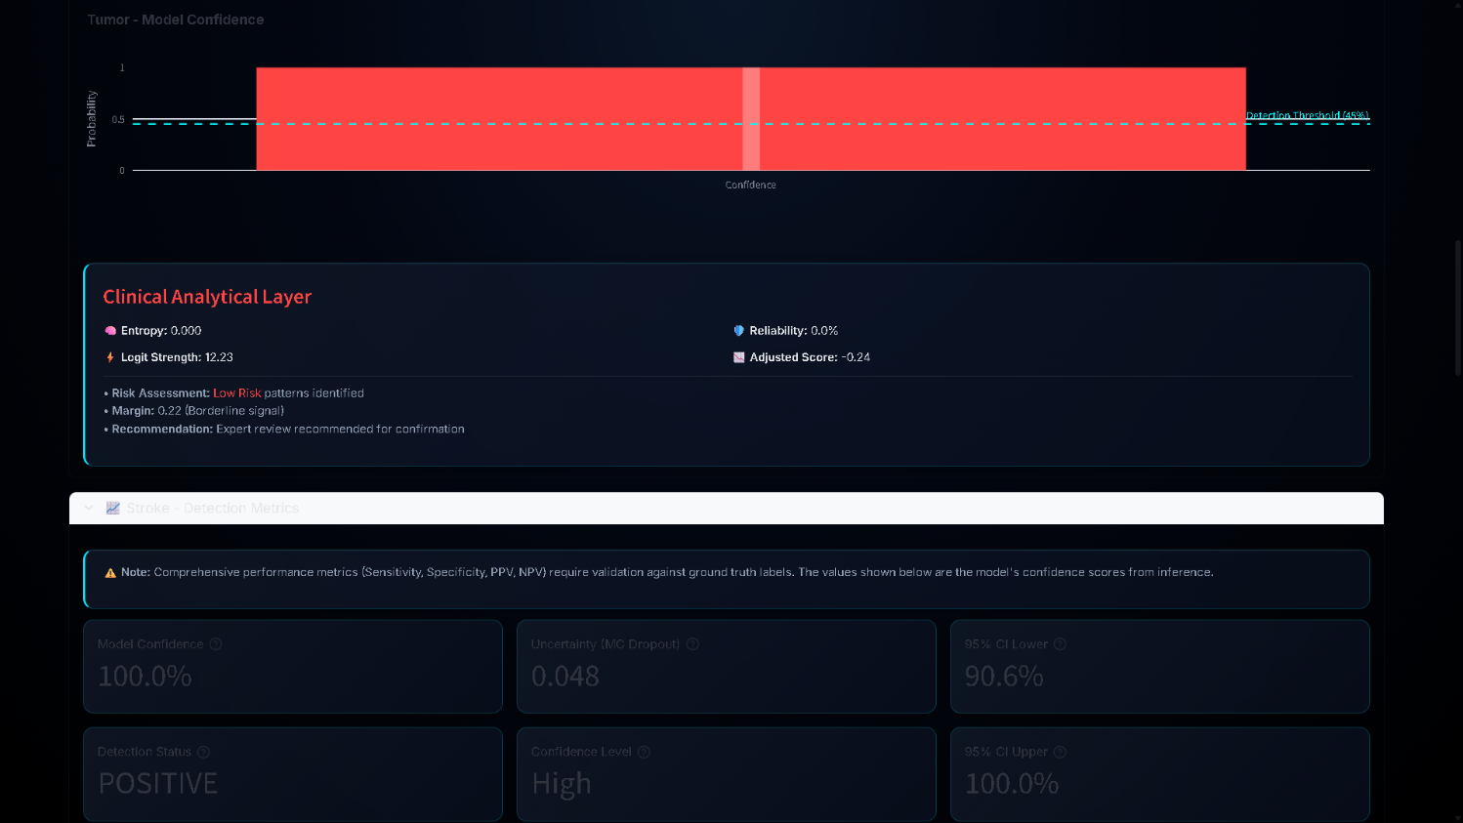
Figure 14 – Tumor modal confidence
For brain tumor analysis, NeuroX uses Medical Image Computing and Computer Assisted Intervention Society BraTS 2020 and 2021, which are widely used glioma segmentation benchmarks. Each BraTS subject contains four MRI modalities:
- T1-weighted imaging
- T1 contrast-enhanced imaging (T1ce)
- T2-weighted imaging
- FLAIR imaging
These modalities provide complementary diagnostic information: T1 captures anatomy, T1ce highlights active tumor tissue, T2 shows edema, and FLAIR improves lesion visibility around infiltrative regions. Each case includes voxel-level labels for:
- Enhancing Tumor (ET)
- Tumor Core (TC)
- Whole Tumor (WT)
A total of 1619 MRI scans were used. The dataset contains variation in lesion size, location, enhancement pattern, edema spread, and scanner source, which improves robustness but increases learning complexity.
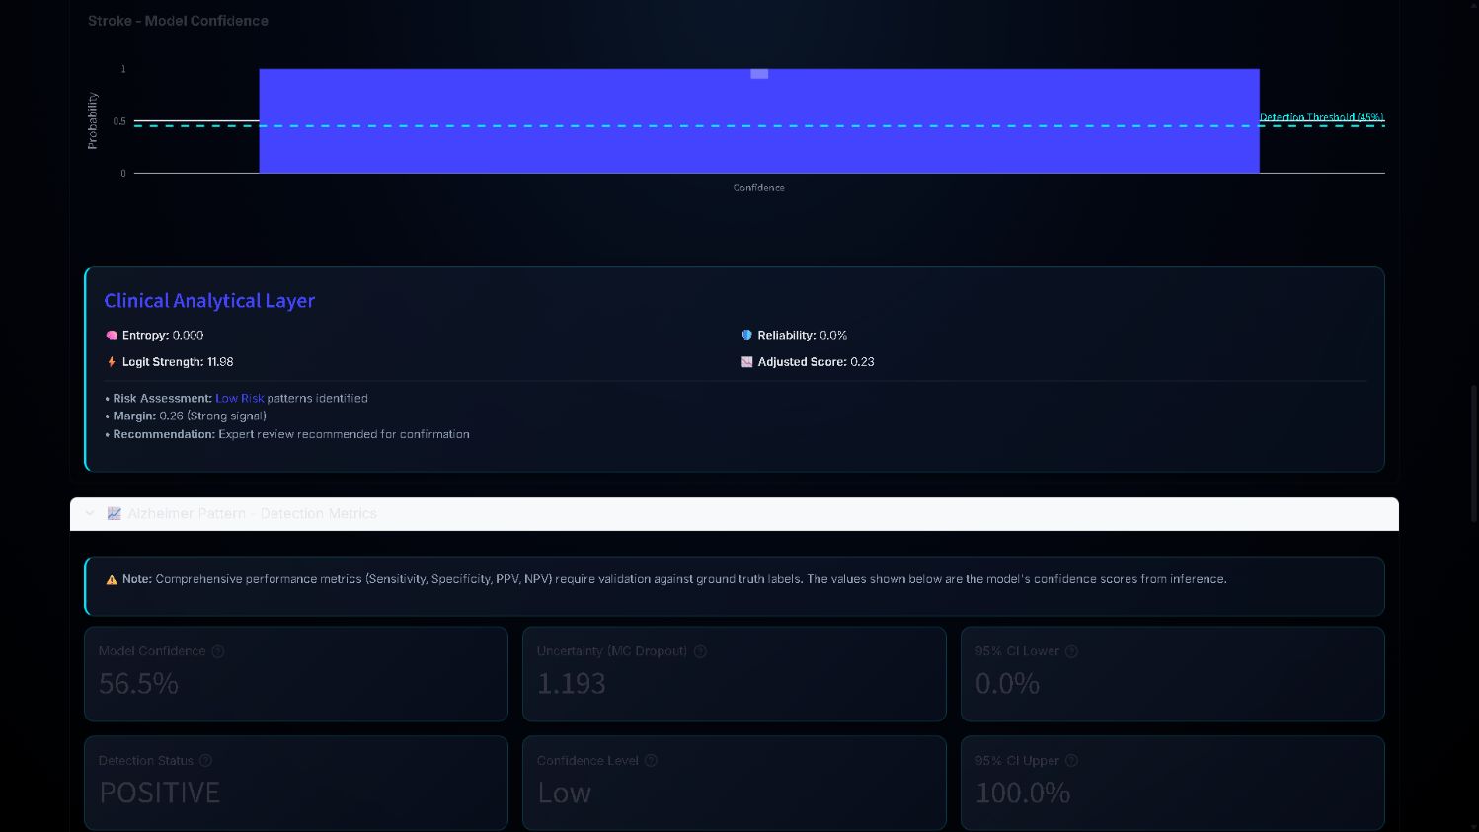
Figure 15 – Strock modal confidence
For stroke analysis, NeuroX uses ISLES Challenge ISLES 2022, which focuses on ischemic stroke lesion segmentation. Stroke lesions differ from tumors because they are often very small, irregular, and occupy limited brain volume. In many cases, lesion voxels represent less than 1% of total brain tissue, creating strong class imbalance. The dataset includes 250 MRI scans with lesion annotations. Because stroke lesions are sparse and subtle, segmentation is more difficult than tumor detection.
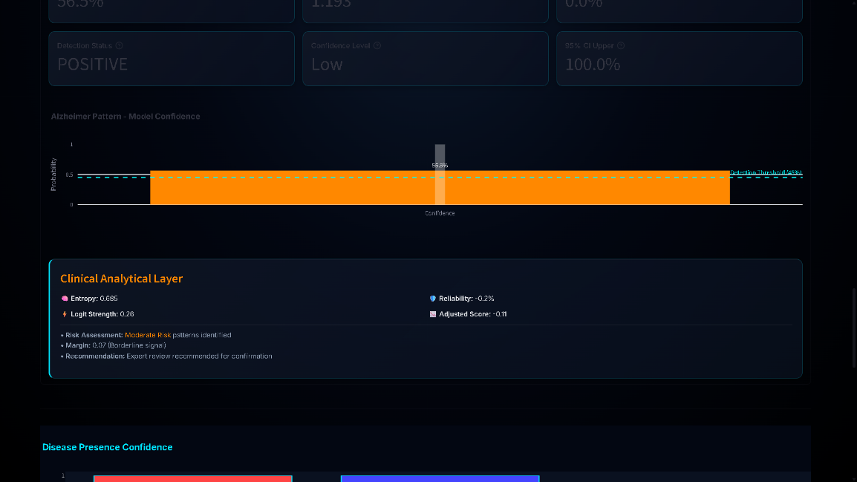
Figure 16 – Alzheimer’s modal confidence
For Alzheimer’s disease classification, NeuroX uses Alzheimer's Disease Neuroimaging Initiative ADNI, which contains structural MRI scans for neurodegenerative analysis. Unlike tumor and stroke datasets, ADNI does not provide lesion masks because Alzheimer’s disease appears through distributed anatomical degeneration rather than focal lesions.
The main structural patterns learned include:
- cortical thinning
- hippocampal shrinkage
- ventricular enlargement
- diffuse tissue redistribution
ADNI includes:
- healthy controls
- mild cognitive impairment
- Alzheimer-positive scans
A total of 1208 MRI volumes were used.
The use of these three datasets allowed NeuroX to learn both focal lesion pathology and diffuse neurodegenerative patterns within one unified framework, making dataset harmonization a critical foundation for model stability and generalization.

Appendix B: Preprocessing and Anatomical Standardization Pipeline
Preprocessing was a critical stage in NeuroX because MRI datasets collected from different institutions contain major variations in intensity distribution, spatial resolution, and anatomical orientation. Without standardization, the model could learn scanner-specific characteristics instead of disease-related features.
Unlike CT imaging, MRI voxel values do not follow fixed physical units. Intensity values depend on scanner hardware, pulse sequence settings, and acquisition conditions, meaning that identical tissues may appear numerically different across datasets. To reduce this variation, NeuroX applies voxel-level Z-score normalization:
$$Z=\frac{X-μ}{σ}$$
This normalization is performed independently for each MRI volume because scanner bias differs across institutions. Outlier clipping is then applied to suppress extreme intensity spikes.
The second preprocessing stage is skull stripping, which removes non-brain regions such as:
- skull
- scalp
- fat tissue
- background air
This step was performed using HD-BET, ensuring that only relevant brain anatomy remains for model input. Skull stripping improves learning reliability because non-brain tissue often introduces scanner-dependent patterns that do not contribute to diagnosis.
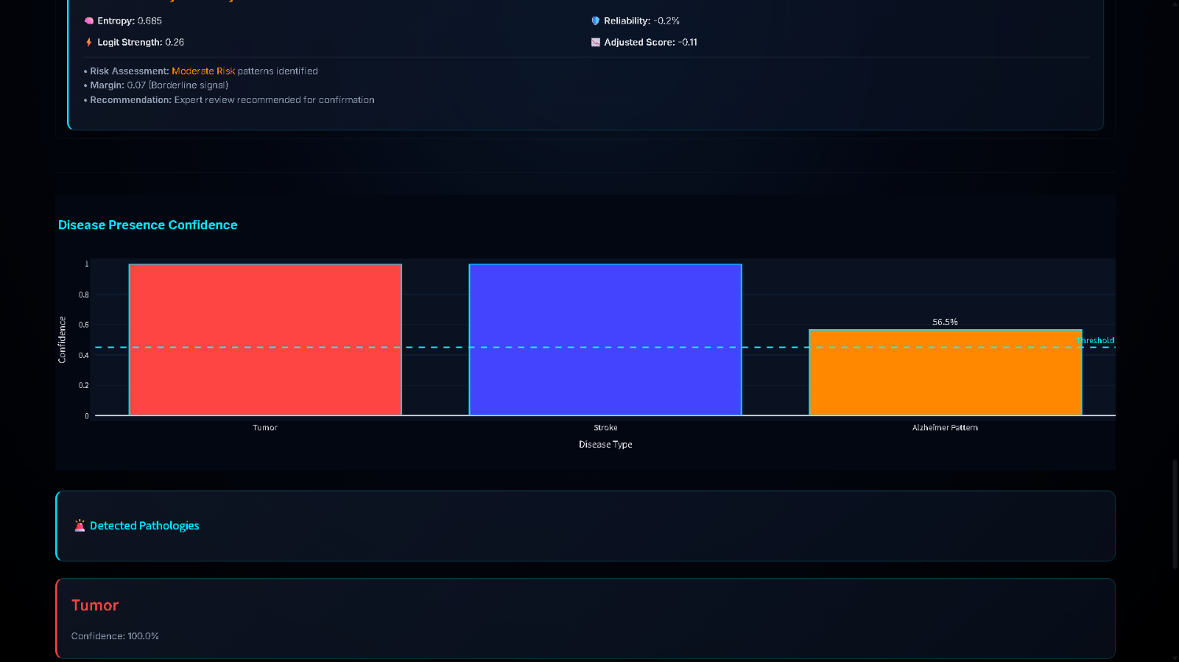
Figure 17 – Disease Presence Confidence

The third stage is spatial resampling. Since MRI volumes vary in voxel size and slice count, all scans were resized to:
96 × 96 × 96
This resolution was selected as a balance between anatomical preservation and GPU memory feasibility. Larger volumes caused excessive memory usage during transformer processing, while smaller volumes reduced lesion detail.
The final stage is orientation correction. Because datasets differ in affine alignment, all MRI volumes were transformed into a common anatomical orientation before tensor conversion. This ensures that lesion positions remain spatially consistent across tumor, stroke, and Alzheimer datasets.
Together, these preprocessing steps created a standardized volumetric input space, allowing NeuroX to learn disease features rather than scanner-specific variation.


Figure 18 – Detected Pathologies

Appendix C: Extended Computational Failure Analysis and Hidden Optimization Constraints
Although final results are stable, many hidden optimization failures occurred during development.
Initial transformer experiments failed because full-resolution attention exceeded GPU memory.
To solve this, transformer attention was applied only after encoder compression.
This reduced token count.
Batch size two was attempted initially.
However:
- GPU memory overflow occurred during decoder reconstruction
Therefore batch size one became mandatory.
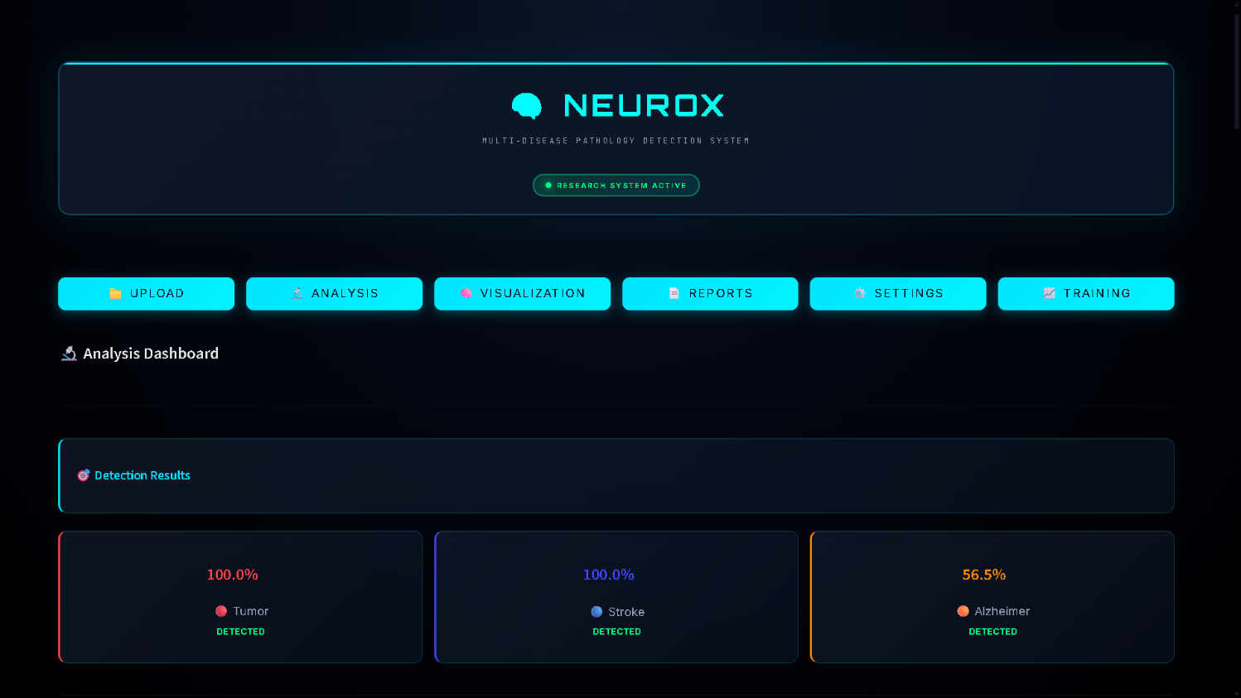
Figure 19 – Analysis Dashboard
This introduced noisy gradients.
Gradient accumulation solved this.
Training instability also occurred when all disease branches were activated immediately.
This produced gradient conflict because:
- lesion tasks demand localized gradients
- Alzheimer branch demands distributed gradients
Therefore phased curriculum became necessary.
Appendix D: Extended Clinical Error Cases and Diagnostic Interpretation Limits
Tumor errors occurred in cases where:
- enhancing tumor thickness extremely small
- lesion contrast weak
Stroke errors occurred when:
- infarcts were punctate
- lesions fragmented across distant voxels
Alzheimer errors occurred in borderline early disease where anatomical changes overlap with normal aging.
These are clinically realistic failure modes and therefore important to document.
Appendix E: Three-Dimensional Visualization of Tumor and Stroke Lesions
The NeuroX framework includes a post-processing module for three-dimensional lesion visualization so that segmented abnormalities can be inspected spatially within brain anatomy. In neurological diagnosis, visual interpretation is important because clinicians often require lesion depth, extent, and anatomical position rather than only numerical predictions. Therefore, segmented tumor and stroke masks are converted into volumetric 3D structures after inference.
After segmentation, binary lesion masks generated by the tumor and stroke branches are transformed into geometric surfaces using the marching cubes algorithm. This method extracts connected lesion boundaries and converts voxel regions into polygonal meshes suitable for rendering while preserving anatomical alignment.
Appendix E.1 Tumor Visualization
Tumor lesions are rendered as red volumetric regions inside a semi-transparent brain model. These regions represent abnormal tissue predicted by the tumor decoder after attention-guided segmentation.
Main advantages of tumor visualization:
- lesion size can be estimated
- spatial depth becomes clear
- relation to surrounding anatomy is visible
- irregular tumor spread is easier to interpret
Compared with slice-based segmentation, 3D rendering reduces the need for manual mental reconstruction across multiple MRI slices.
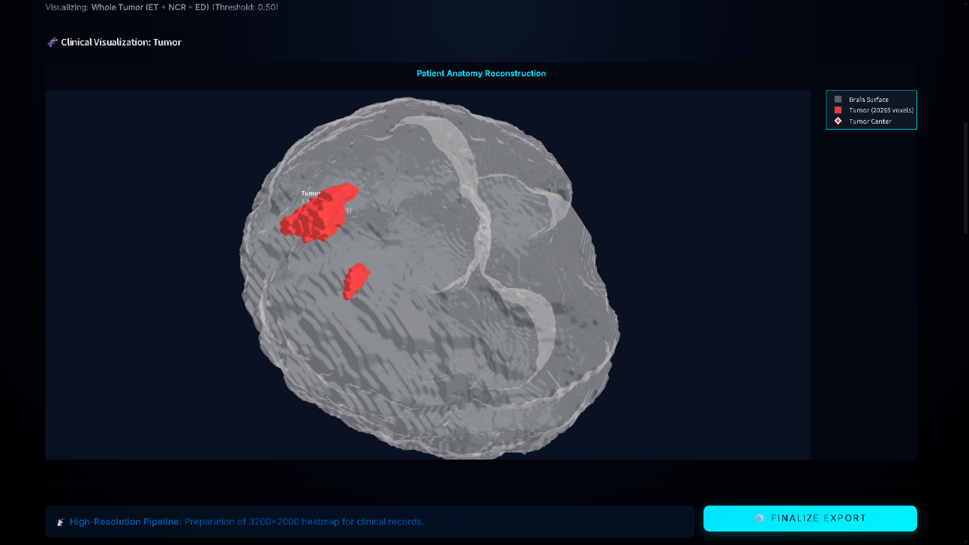

Figure 20 & 21 – Tumor Visualization
Appendix E.2 Stroke Visualization
Stroke lesions are rendered as blue volumetric regions within the same transparent brain structure. Unlike tumors, stroke lesions are often thinner, smaller, and fragmented.
Stroke visualization helps in:
- identifying vascular lesion spread
- recognizing fragmented infarcts
- estimating lesion burden
This improves interpretation because small stroke lesions may be difficult to understand in individual slices.
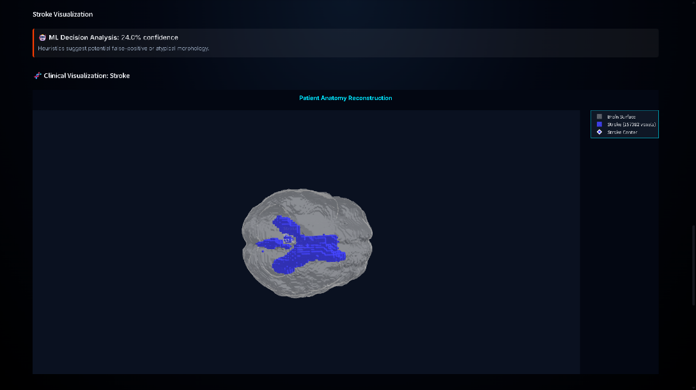

Figure 22 & 23 – Strock Visualization
Appendix E.3 Rendering Pipeline
The visualization pipeline was implemented using Plotly inside the deployed dashboard.
Processing steps include:
- segmented voxel extraction
- binary refinement
- marching cubes surface generation
- mesh rendering
- interactive rotation and zoom
The brain surface is displayed as semi-transparent anatomy so lesion position remains visible.
Appendix E.4 Clinical Relevance and Limitations
Three-dimensional visualization improves trust because clinicians can inspect:
- lesion volume
- anatomical depth
- lesion orientation
- relative location
However, some limitations remain:
- very small lesions may appear fragmented
- surface smoothing can reduce edge detail
- thin lesions may appear discontinuous
Future improvements may include higher mesh resolution and multimodal overlay support.
Appendix F: Automated Clinical Report Generation Module
The NeuroX framework includes an automated report generation module that converts model predictions into structured clinical documentation. Since numerical outputs alone are difficult to interpret in practice, the system generates readable summaries describing detected abnormalities, lesion characteristics, and prediction confidence.

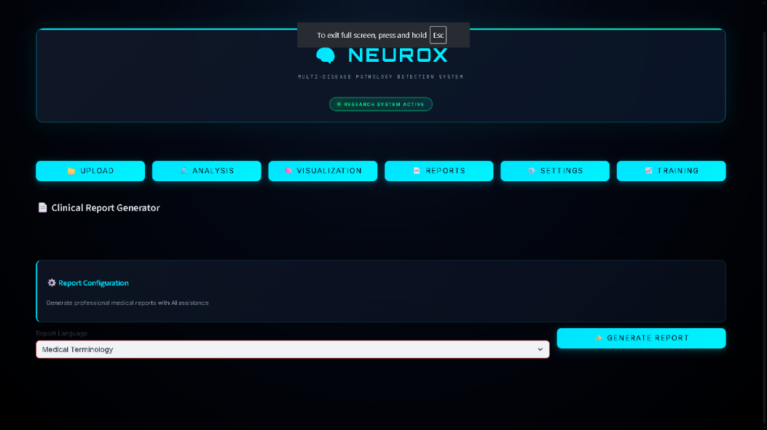
Figure 24 – Report Generation Dashboard
The reporting module is integrated into the deployed Streamlit interface and activates after MRI analysis is completed. Once inference finishes, outputs from tumor segmentation, stroke detection, Alzheimer classification, and uncertainty estimation are collected and formatted into a structured report.
Report Generation Workflow
The report follows this sequence:
- MRI processed through NeuroX
- Disease outputs collected
- Lesion statistics calculated
- Confidence extracted
- Structured text generated
- Final report exported
For tumor and stroke cases, lesion masks are used to estimate lesion volume and approximate anatomical location. For Alzheimer analysis, the report includes predicted disease probability.


Figure 25 – Final report of the MRI

Report Content
The generated report includes:
- detected disease type
- lesion presence
- lesion volume estimate
- anatomical summary
- confidence score
- uncertainty note
Typical outputs include statements such as:
- abnormal enhancing lesion identified
- ischemic lesion detected
- Alzheimer probability elevated
Clinical Value and Limitations
A major strength of NeuroX reporting is the inclusion of confidence information derived from Monte Carlo dropout, allowing uncertain cases to be flagged for expert review.
Main benefits:
- reduces manual reporting time
- improves output consistency
- supports deployment readiness
Current limitations include template-based language and limited customization. Future versions may integrate adaptive medical language generation.

